**GROUP PROJECT - REVISED**

**Churn Analytics for Credit Card Customers**

Applied Analytic Modelling (BA706)

Tutor: David Parent

10TH JULY 2023

|  |  |
| --- | --- |
| **Group 3** | |
| DARREN CARVALHO | 301251637 |
| SUDISH BASNET | 301250603 |
| JAGJEET SINGH MALHOTRA | 301263211 |
| OMPRAKASH BISTA | 301251726 |

TABLE OF CONTENTS

1 Introduction 4

1.1 Problem Statement 4

1.2 Objective 4

2. Business Understanding for Churn Analytics 4

2.1 Finance 4

2.2 Banking 4

2.3 Stakeholder analysis 4

3. Data Description 5

4. Data Preparation – ETL 6

5. Summary statistics for Numerical / Categorical Variables 8

5.1 Customer Age, Credit limit in each income group for both the target classes 9

5.2 Gender wise proportion of card categories 9

6. Transformations / Cap and Floor / Replacing Unknown with Mode 10

6.1 Log Transformation 11

6.2 Cap and Floor 11

7. Modelling 12

7.1 Decision Tree Models 12

7.1.1 Maximal Tree 12

7.1.2 Misclassification Tree 13

7.1.3 Probability Tree 15

7.1.4 3 Leaves Tree 15

7.1.5 Summary 16

7.1.6 Inferences from this model 17

7.2 Logistic Regression 17

7.2.3 Full Regression 17

7.2.2 Forward Regression 20

7.2.1 Backward Regression 23

7.2.4 Stepwise Regression 26

7.3 Neural Networks 29

7.3.1 Model with preliminary training enable vs disable 29

7.3.2 Decision tree neural network 30

7.3.3 2 Hidden unit's neural network 31

7.3.4 4 Hidden unit’s neural network 32

7.3.5 6 Hidden unit’s neural network 33

7.3.6 100 Iteration neural network 34

7.3.7 Recoded variable neural network 35

7.3.8 Stepwise regression neural network 36

7.3.9 Summary table for neural network model 37

7.3.10 Model Assessment 38

8. Models Comparison 41

9. Conclusion 42

10. Business Report 44

11. References 44

# 1 Introduction

## 1.1 Problem Statement

In the world of finance, Banks have been facing a lot of issues which are mostly associated with the financial services provided by the respective financial institution. One of the major problems with financial services is credit card churning. This is a situation where a credit card company experiences a high rate of customers withdrawing their credit cards and switching to another company's card or taking other possible actions. This act of customers can lead to loss in high revenue from the cancelled cards, and it also incurs the cost of acquiring new customers to replace the ones who have churned. There are various reasons that can influence a user to withdraw the credit card services. One of the reasons can be customers using the service bonuses and getting rid of it before the end of the year to avoid the fee and later the same process is repeated with the other card. Other reasons associated with this can be client affordability, credit card points or credit limit, card category, and client backgrounds like gender, education, marital status, dependents, and livelihood.

## 1.2 Objective

The purpose of this analysis is to know the reason behind churn and recommend solutions according to the reasons. To do this analysis, a credit card company can use data mining and machine learning techniques to analyze customer behavior and identify potential churners by predicting the target variable associated with different entities from the dataset of customer’s information. So, with the identification of customers and the reasons with churn analytics, the company can take proactive steps to retain them, such as offering special promotions or incentives. This can help reduce the churn rate and increase customer loyalties.

# 2. Business Understanding for Churn Analytics

## 2.1 Finance

In the finance industry credit card churning is one of the common practices seen among the customers as the customer tends to switch service providers or quit the services after using all the special offers and bonuses.

## 2.2 Banking

In banking, Institutes use advertising as a tool to create hope among new and long-term clients. So, they prevent churning by having regulations to reduce the churning practice among the customers.

## 2.3 Stakeholder analysis

There is a churning which happens among internal stakeholder for e.g.: The employee working in the bank can involve in churning to get extra commission without knowing the fact that the customer will be finding that credit card services in his favor or not. The external stakeholders are the customers who are the most important aspect of the business, so their trust in accepting the services provided by the bank is a win-win situation in both ends.

# 3. Data Description

Credit card customers dataset consists of 10,000 customers mentioning their information like age, marital status, salary, credit card limit, credit card category, etc. In total, we have 24 attributes, out of which we will use the attrition flag as a target variable so that we can predict the churn. Simultaneously, the remaining attributes will be used as features to predict the target variable. However, after some exploratory data analysis, some features may be rejected as per their importance to our churn analytics.

In detail, our data description is explained below in the table as per the attributes. The dataset was taken from Kaggle (Kaggle, 2022).

|  |  |
| --- | --- |
| **Column** | **Description** |
| CLIENTNUM | Client number. Unique identifier for the customer holding the account |
| Customer_Age | Demographic variable - Customer's Age in Years |
| Dependent_count | Demographic variable - Number of dependents |
| Marital_Status | Demographic variable - Married, Single, Divorced, Unknown |
| Card_Category | Product Variable - Type of Card (Blue, Silver, Gold, Platinum) |
| Total_Relationship_count | Total no. of products held by the customer |
| Contacts_Count_12_mon | No. of Contacts in the last 12 months |
| Total_Revolving_Bal | Total Revolving Balance on the Credit Card |
| Total_Amt_Chng_Q4_Q1 | Change in Transaction Amount (Q4 over Q1) |
| Total_Trans_Ct | Total Transaction Count (Last 12 months) |
| Avg_Utilization_Ratio | Average Card Utilization Ratio |
| Attrition_Flag | Internal event (customer activity) variable - if the account is closed then 1 else 0 |
| Gender | Demographic variable - M=Male, F=Female |
| Education_Level | Demographic variable - Educational Qualification of the account holder (example: high school, college graduate, etc.) |
| Income_Category | Demographic variable - Annual Income Category of the account holder (< $40K, $40K - 60K, $60K - $80K, $80K-$120K, > |
| Months_on_book | Period of relationship with bank |
| Months_Inactive_12_mon | No. of months inactive in the last 12 months |
| Credit_Limit | Credit Limit on the Credit Card |
| Avg_Open_To_Buy | Open to Buy Credit Line (Average of last 12 months) |
| Total_Trans_Amt | Total Transaction Amount (Last 12 months) |
| Total_Ct_Chng_Q4_Q1 | Change in Transaction Count (Q4 over Q1) |
| Naive_Bayes_Classifier_attribution | Naive Bayes |
| Naive_Bayes_Classifier_attribution | Naive Bayes |

# 4. Data Preparation – ETL

The data appears to be highly imbalanced with only 16.06 % of the target as churned customers. To create a balanced target, a random sample of the size of churned customers was extracted from the existing customers and these were merged to form our data for modelling. The data contained ~3000 records after the down sampling which is still appropriate for modelling.

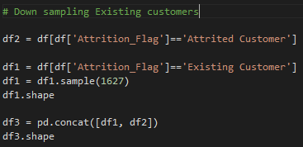

Since the target variable is binary, Attrition Flag is set to binary. ID, NBS1 and NBS2 are the variables which would be rejected. ID is a unique variable, and the target does not have any dependency on ID. NBS1 and NBS2 are variables created by the author which are results from a naïve bayes classification model. Explaining models can be difficult as it is not clear how and why these two variables were created.

Screenshot of the Data categories / rejections

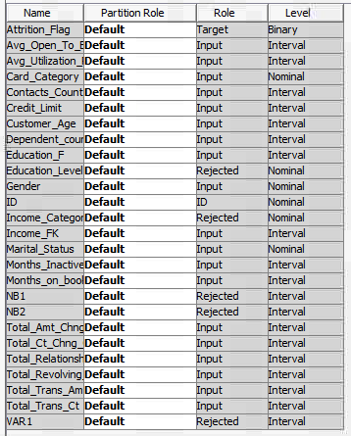

During initial understanding of the data, two variables occur to be ordinal and can be ranked rather than creating dummy variables. Education Level and Income categories which have 7 and 6 unique values respectively. This encoding is expected to affect the regression and neural networks model due to the model requirements. A separate model evaluation with adding these rank encoded variables will be tested and the impact on performance will be observed. The ranking will be numeric with highest given to the most educated “Doctorate” in our case and maximum earning category which is “$120k +” in our case.

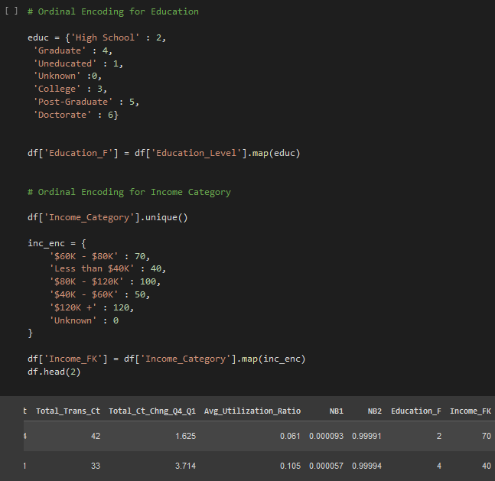

# 5. Summary statistics for Numerical / Categorical Variables

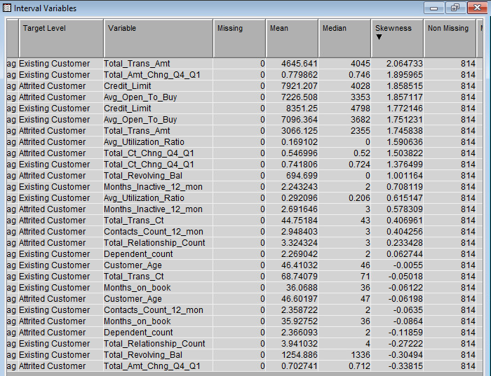

Numerical variables did not contain any missing values but there were a few variables which were skewed. Three categorical variables (Education level, Marital Status, and Income Category) contained fields labelled unknown which have been considered as missing.

## 5.1 Customer Age, Credit limit in each income group for both the target classes

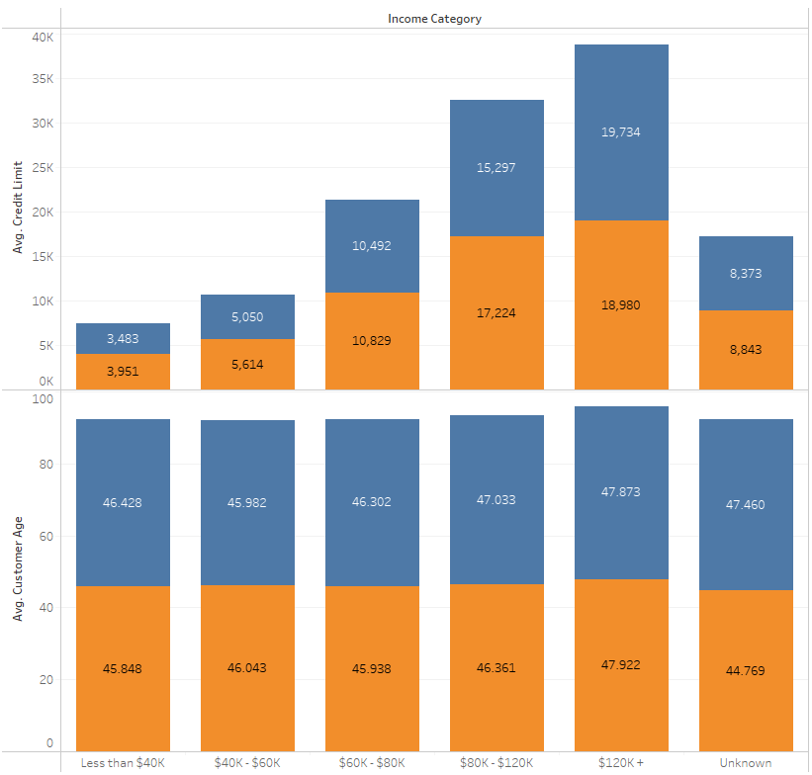 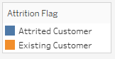

*Average customer age and Average credit limit in each income category for both the classes.*

As expected, the credit limit increases with an increase in the income. The average age for all income categories was around 44-45 years, which is probably the target group for the survey. There were no extreme or unique values for either of the classes as they showed similar trends for each income group; credit limit and age.

## 5.2 Gender wise proportion of card categories

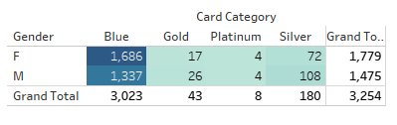

As expected, most of the customers use the blue card category as the rest may have some annual fee or other restrictions upon it. The proportion of females is highest in the blue category while for other cards, the proportion of male is higher. The platinum users are only 8 among 3000 which would not be significant enough to model, as a result creating a model with blue card category as a class against all other card categories in one class may provide significant results.

# 6. Transformations / Cap and Floor / Replacing Unknown with Mode

There are 4 variables which were skewed. Average utilization Ratio, Credit Limit, Total Transaction Amount, Average open to buy. These 4 variables were skewed for both the classes Existing and Attired customers. There were other variables as well with skewness but those were with respect to one class only which could be an impacting factor on the target and the skewness value was not very significant. As a result, we decided to perform skewness on these 4 variables. Our rational statistical technique to resolve the skewness was that the ones with higher skewness statistic were log transformed and the ones with lower skewness statistic were handled using cap and floor.

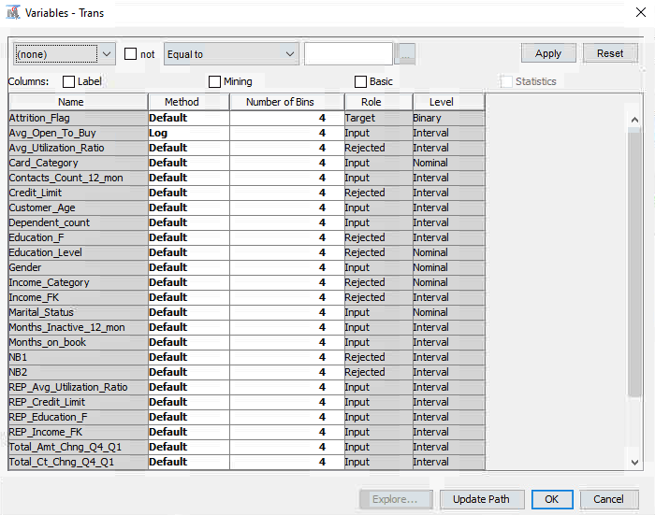

## 6.1 Log Transformation

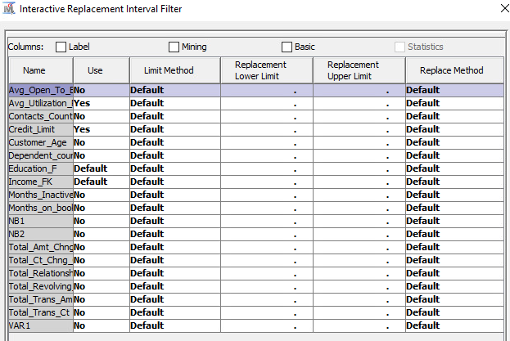

## 6.2 Cap and Floor

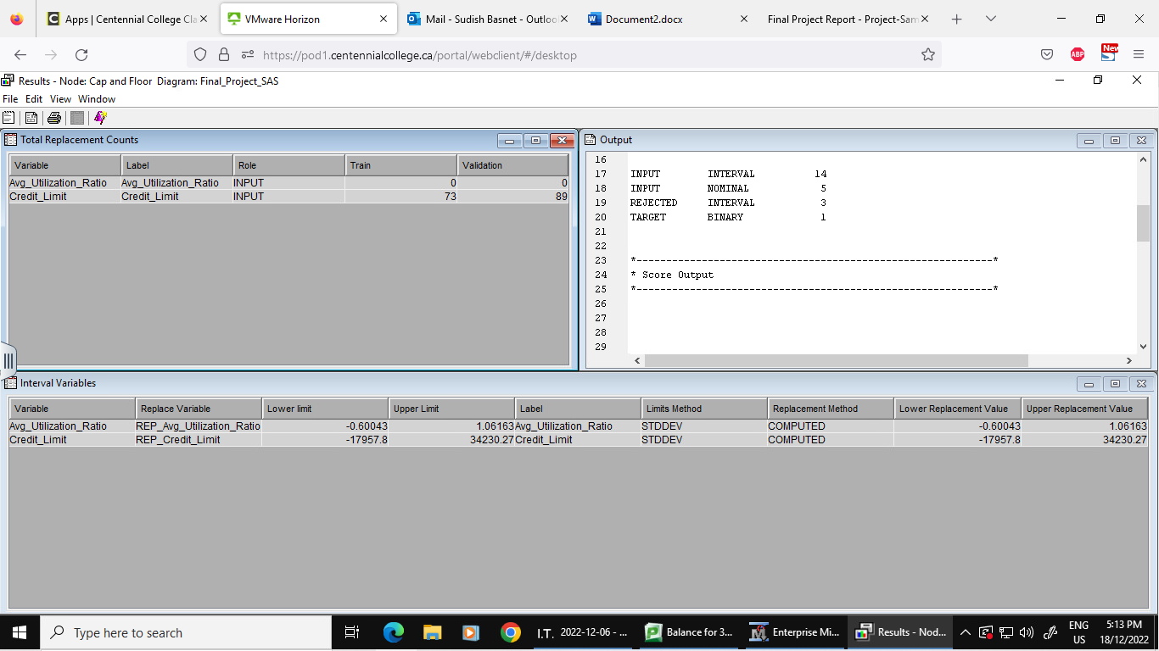

Interval variables did not contain any missing values. While there were 3 class variables Education level, Marital Status and Income Category which contained a class unknown. We considered unknown to be a missing field and the probable reason for unknown is that the information may seem confidential and people undertaking the survey may not have wanted to answer this question. We could create a model with these variables as it is not necessary that customers want to share such details and we could have a custom class for such input. But the unknown class could contain a vast number of customer categories which may or may not include the predefined classes among the variables. For instance, unknown in marital status could mean married but do not want to share details, divorced, or even single and this could impact model performance. As a result, we decided to impute the missing values with the mode from each variable.

# 7. Modelling

## 7.1 Decision Tree Models

Tree was used as the first predictive model, as Tree does not require any data handling or such; we can pass dirty data to it and it can give us the important variables. So, to understand the data more we used Tree as the first model.

### 7.1.1 Maximal Tree

Data was imported and connected to the data partition node; the data partition node split the data into 50:50. That is 50% for training and 50% for validation. After this, a decision Tree node was brought in and Maximal tree was produced.

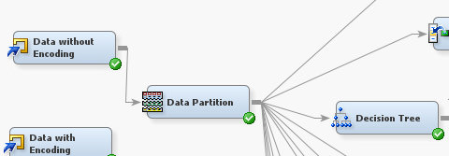

And the following changes were made to the properties:



The results for this tree were as follows:

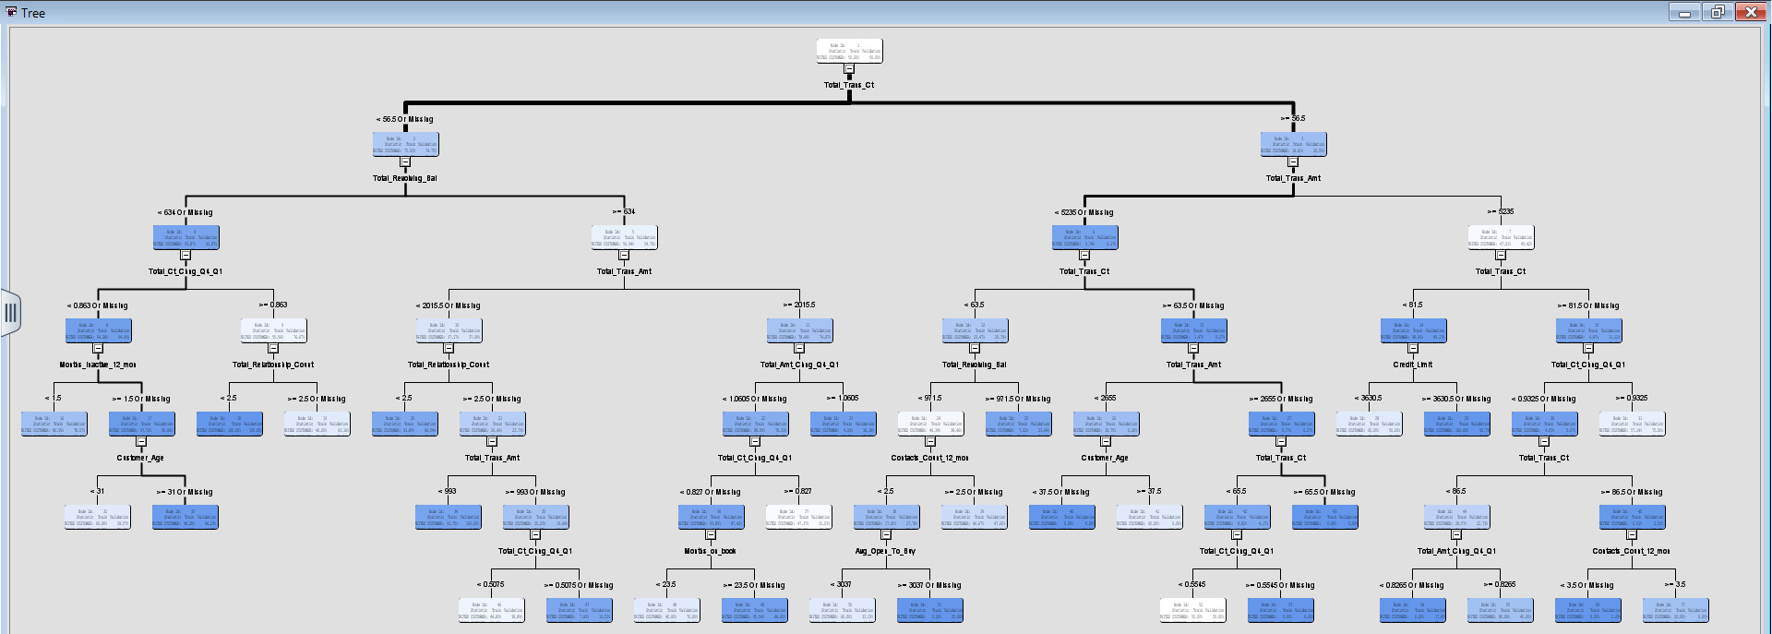

So, we got a maximal tree after splitting was done for all the leaves having a logit value greater than 0.07. So, we got a tree with 29 leaves.

The misclassification rate for this tree was found to be: 0.105166.

With this Tree we can find out that, the maximum number of attired customers are caused by the following variables: Total_Trans_Cnt plays an important role and is the first split in the tree, followed by Total_Revolving Balance.

So, we can see that at node 17, the validation score for 405 customers is 95%, which shows that our model has a good build quality. So, we can conclude that the Customers having transaction counts less than 56.5 and a revolving balance less than 634 with inactive years close to 1.5 have a higher chance of getting churned, so we need to formulate our marketing strategy keeping these people in mind.

### 7.1.2 Misclassification Tree

Now to reduce the curse of dimensionality we start pruning the tree and keeping the assessment value to be misclassification rate. So, we bring in another decision tree node and connect it to the data partition node.

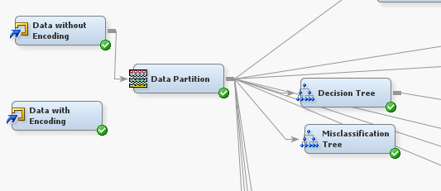

The following changes were made to the properties panel:



Now we run the node and find the pruned tree, the results were as follows:

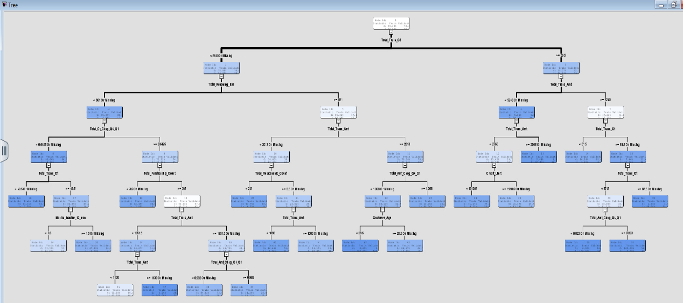

The number of leaves was reduced from 29 to 21 and the value for misclassification rate was also reduced to 0.096556.

### 7.1.3 Probability Tree

Now we changed the assessment value to Average square error in the decision tree node and connected it to the data partition.

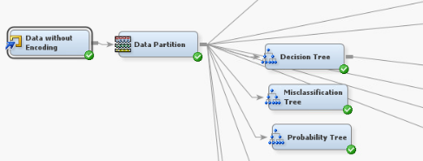



We can find that the misclassification rate increased to 0.099 so this model is not better than the previous model, so we do not select this model.

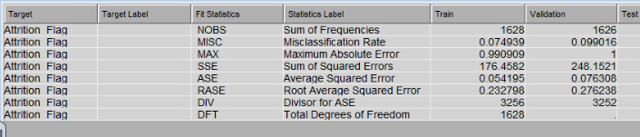

### 7.1.4 3 Leaves Tree

In our models above, we could see that the tree was splitting at same variables again and again. To overcome that, we set the number of branches to 3 and assessment method set to misclassification and check for the misclassification rate.

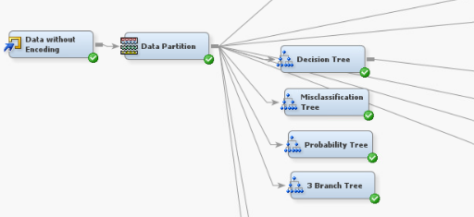

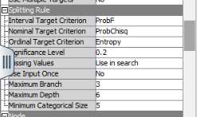

It does reduce the number of leaves from 29 to 20 but the misclassification rate does not improve and the value for it is 0.10 which is not better than the normal misclassification tree. So, we reject this model as well.

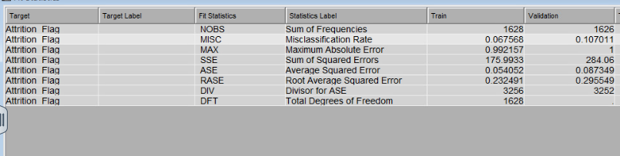

### 7.1.5 Summary

We can find that the misclassification tree is the best tree, with the minimum misclassification rate. The summary for misclassification rates can be found in the table below.

|  |  |  |
| --- | --- | --- |
| Sr. No | Decision Tree Model | Misclassification Rate (Validation Data) |
| 1 | Maximal Tree | 0.105166 |
| 2 | Misclassification Tree | 0.095941 |
| 3 | Probability Tree | 0.099016 |
| 4 | 3 Branch Misclassification tree | 0.107011 |

### 7.1.6 Inferences from this model

So, we found out Total transaction count, total revolving balance, and total transaction amount play an important role in deciding if a customer would churn or not. With our analysis, we found out that for a customer having total transaction count less than 56.5 and total revolving balance less than $634, there is a 93% chance of the customer churning. So, we need to focus on these customers and send some promotional messages or email to such customers so that they do not churn and are retained.

### 7.2 Logistic Regression

### 7.2.3 Full Regression

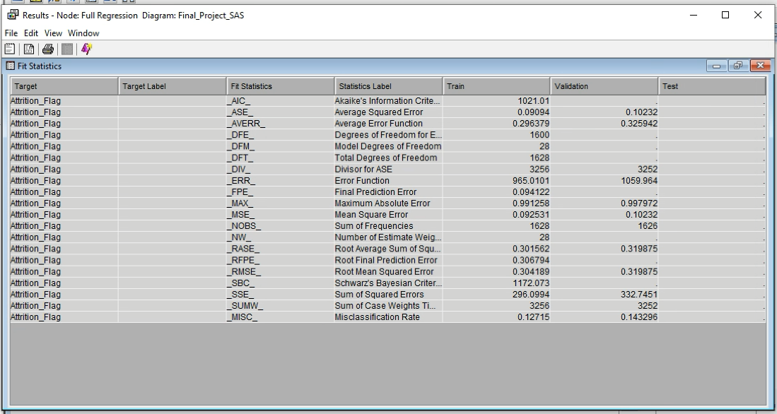

Misclassification rate for validation in Full regression is 0.143296.

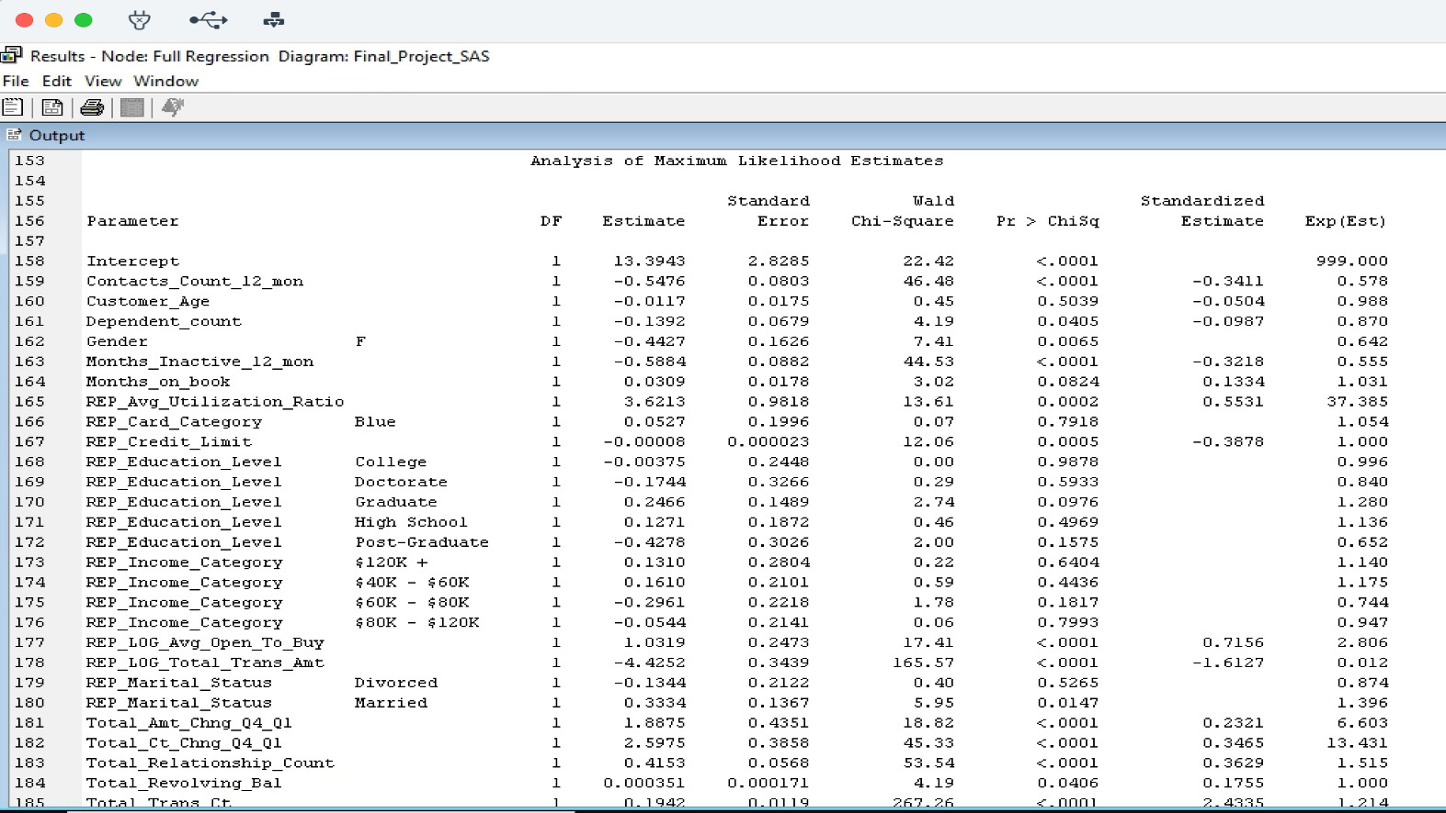

*Full regression analysis Based on valid chi-square.*

As the highest valid chi-square for full regression model is with the parameter Total_Trans_Ct, that is 267.26. As a result, it is the most important variable based on valid chi-square followed by REP_LOG_Total_Trans_Amt which is 165.57, it is second important variable to be look after. Third important variable is Total_Relationship_Count which is 53.54 and least valid chi square variable is REP_Education_Level college which is 0.00.

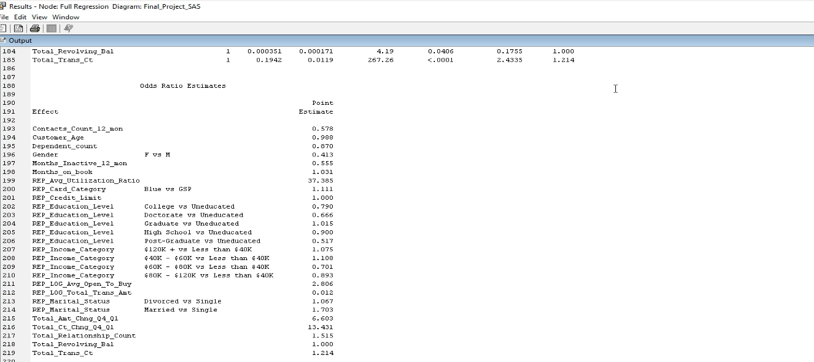

The odds ratio estimate for full regression is as follows.

* Increase in customer age has 1.2% less chance of churning.
* Male has 59% chance of churning compared to female.
* People who are educated are 21% less likely to churn against people who are uneducated.
* A person having an income of more than $120K is less likely to churn compared to individuals having an income of less than $40k.
* People who are divorced are 6.7% less likely of getting churned compared to people who are single.
* Customers having blue cards have 11% less likely of being churned while compared to GSP card category.

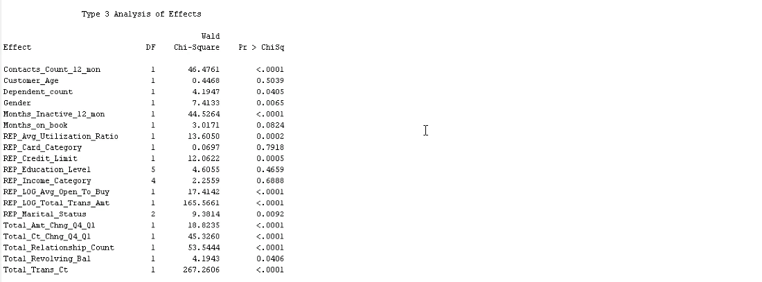

### 7.2.2 Forward Regression

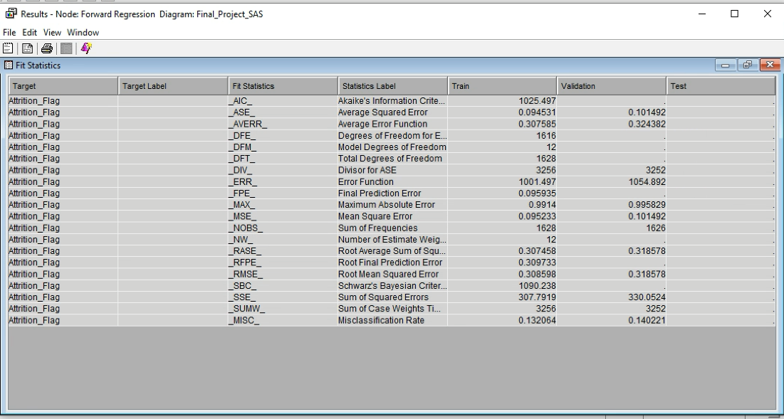

The validation for Target variable Attrition Flag has a misclassification Rate of 0.140221.

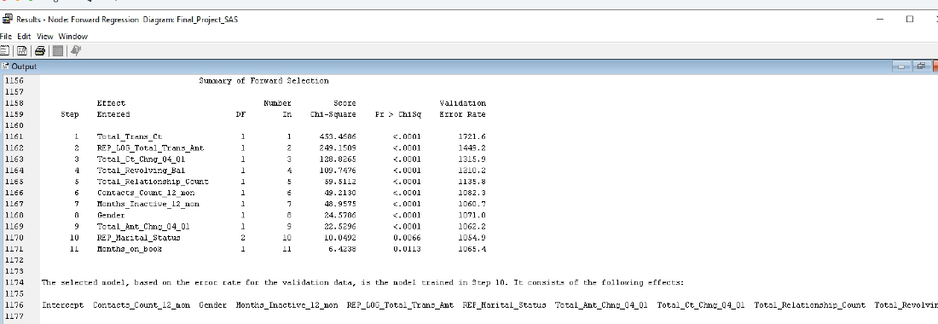

And the intercept which was not visible in screenshot was Total_Trans_Ct.

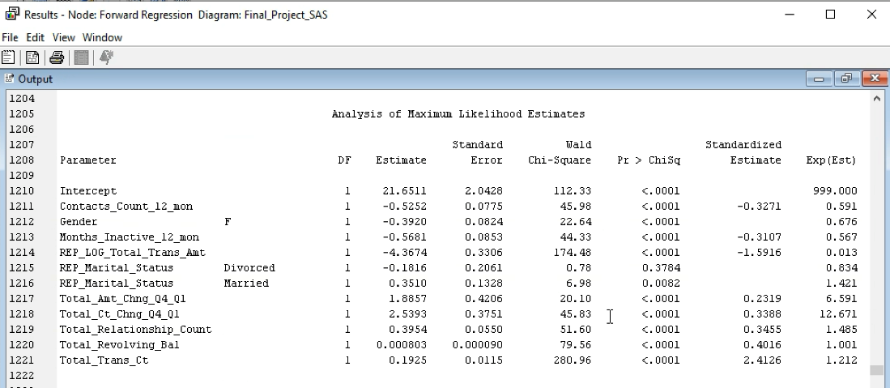

*Forward regression analysis Based on valid chi-square.*

As the highest valid chi-square for forward regression model is with the parameter Total_Trans_Ct that is 280.96. As a result, it is the most important variable based on valid chi-square followed by REP_LOG_Total_Trans_Amt which is 174.48 (Second important variable to be look after). Third important variable is Intercept which is 112.33 and least valid chi square variable is REP_Marital_Status divorced which is 0.78

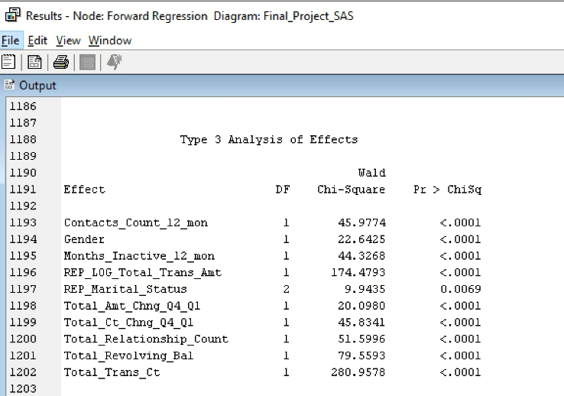

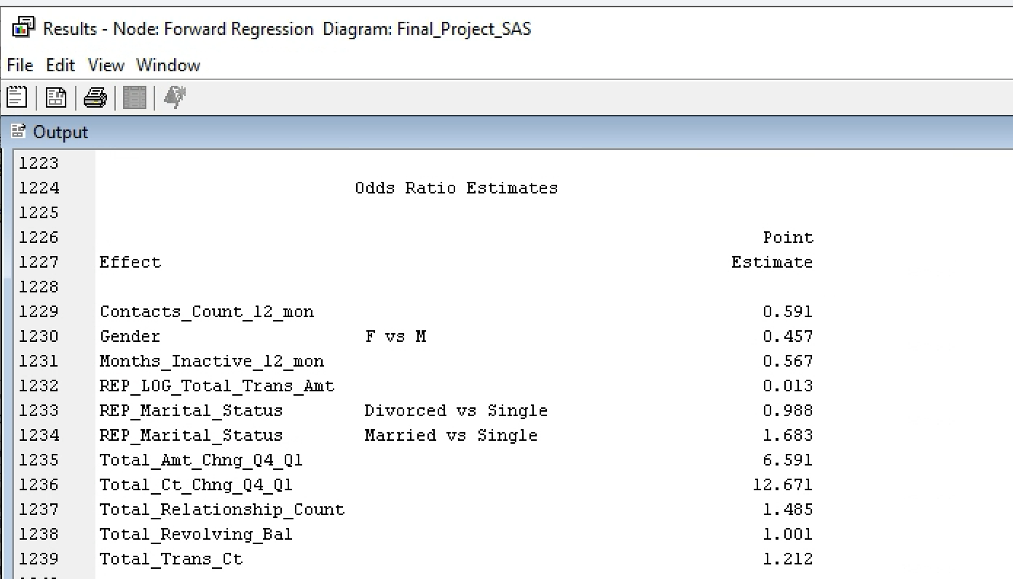

Odds ratio for forward regression is as follows.

* Male has 54% chance of churning compared to female.
* Contacts having count 12 months has 41% less chance of churning.
* People who are divorced are more likely to churn by 1.2% compared to single people.
* Total amounts change in Q4-Q1 increases with 559% of churning.
* With increase in relationship counts, churn increases by 48.5%.

### 7.2.1 Backward Regression

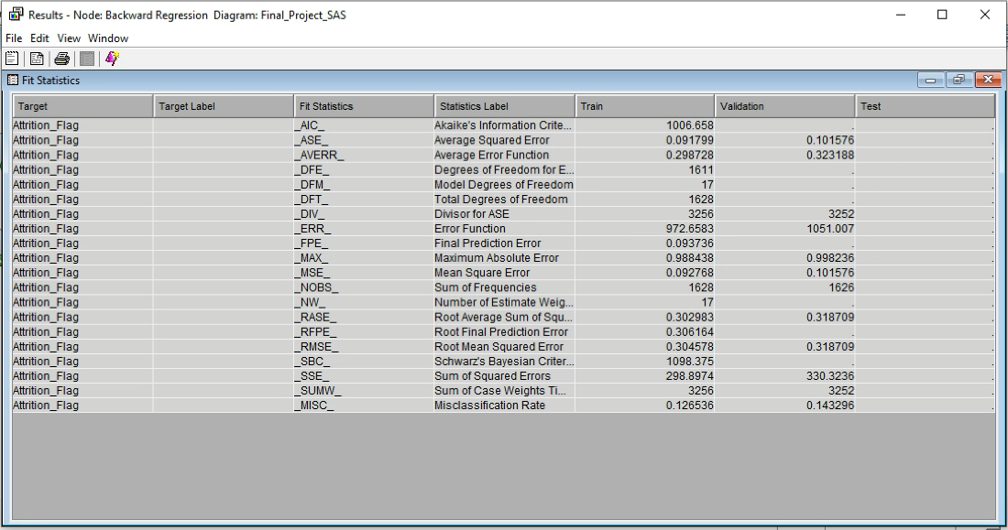

Misclassification rate for validation in Backward regression is 0.143296.

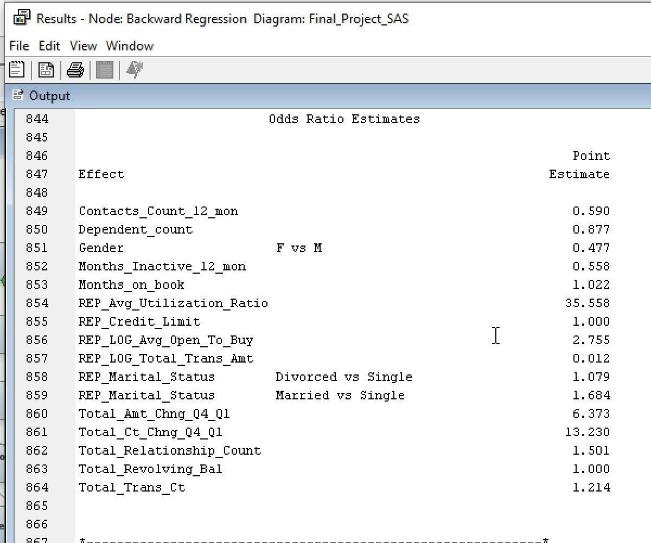

The results are Point estimates for the Odds Ratio Estimates for Backward Regression as follows:

* In gender, male are 52.3% likely to churn compared to female.
* People who are inactive for 12 months have 44% less chance of being churned.
* Average utilization ratio of card has 3,555% chance of churning.
* People who are married have 68.4% of churning compared to single people.
* Dependent count is 12.3% less likely to be churned.
* People who are on books for months increases by 2.2% to churn. 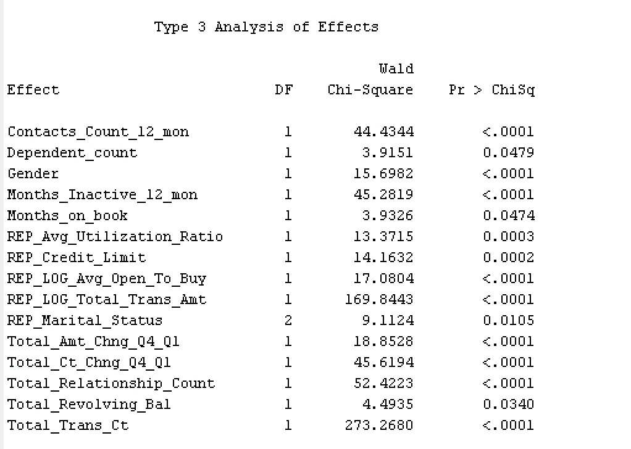

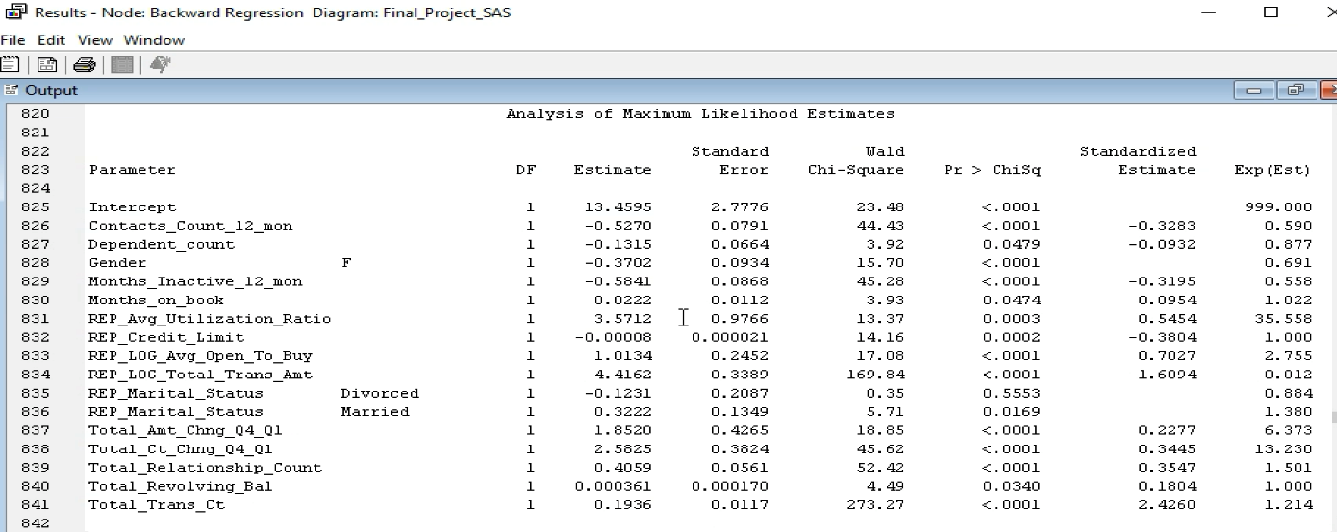*Backward regression analysis Based on valid chi-square.*

As the highest valid chi-square for backward regression model is with the parameter Total_Trans_Ct that is 273.27. As a result, it is the most important variable based on valid chi-square followed by REP_LOG_Total_Trans_Amt which is 169.84 (Second important variable to be look after). Third important variable is Total_Relationship_Count which is 52.42 and least valid chi square variable is REP_Marital_Status Divorced which is 0.35.

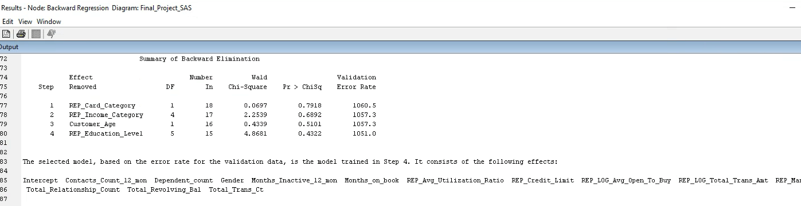

### 7.2.4 Stepwise Regression

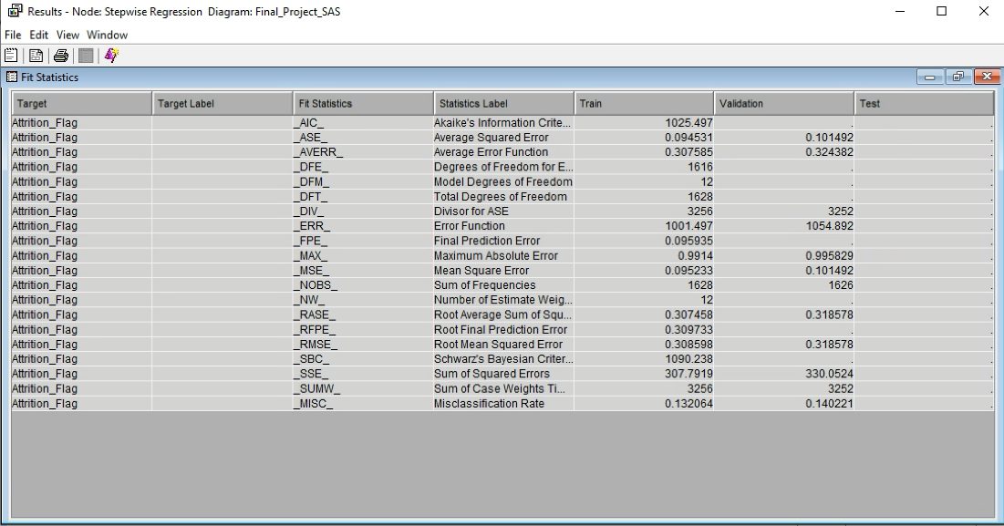

Misclassification rate for validation in Stepwise regression is 0.140221.

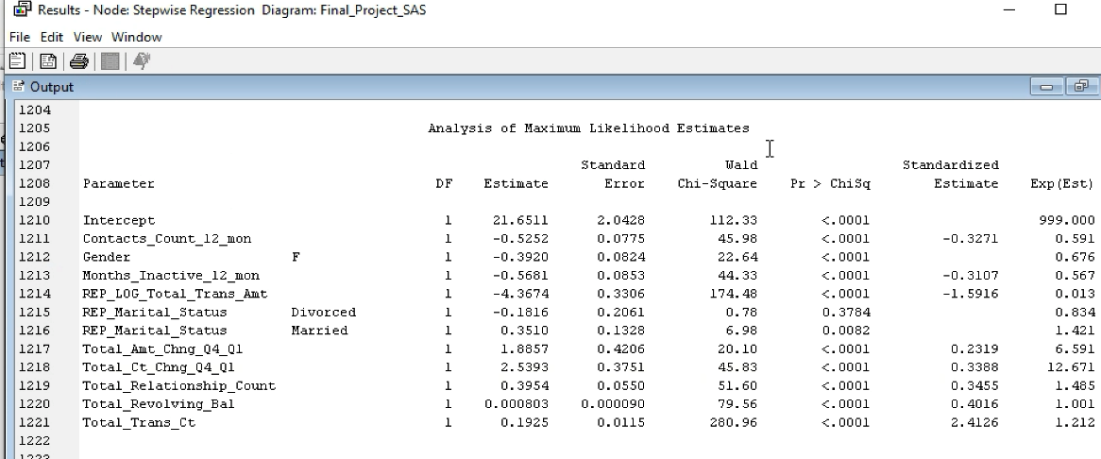

*Stepwise regression analysis Based on valid chi-square.*

As the highest valid chi-square for Stepwise model is with the parameter Total_Trans_Ct that is 280.96; it is the most important variable based on valid chi-square followed by REP_LOG_Total_Trans_Amt which is 174.48 (Second important variable to be look after). Third important variable is Intercept which is 112.33 and least valid chi square variable is REP_Marital_Status Divorced which is 0.78.

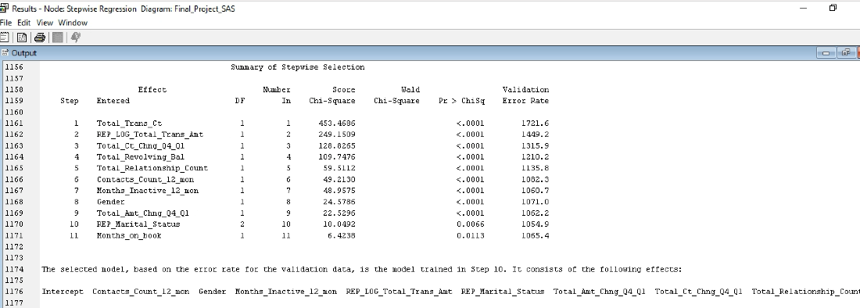

And the intercept which was not visible in screenshot are Total_Revolving_Bal and Total_Trans_Ct.

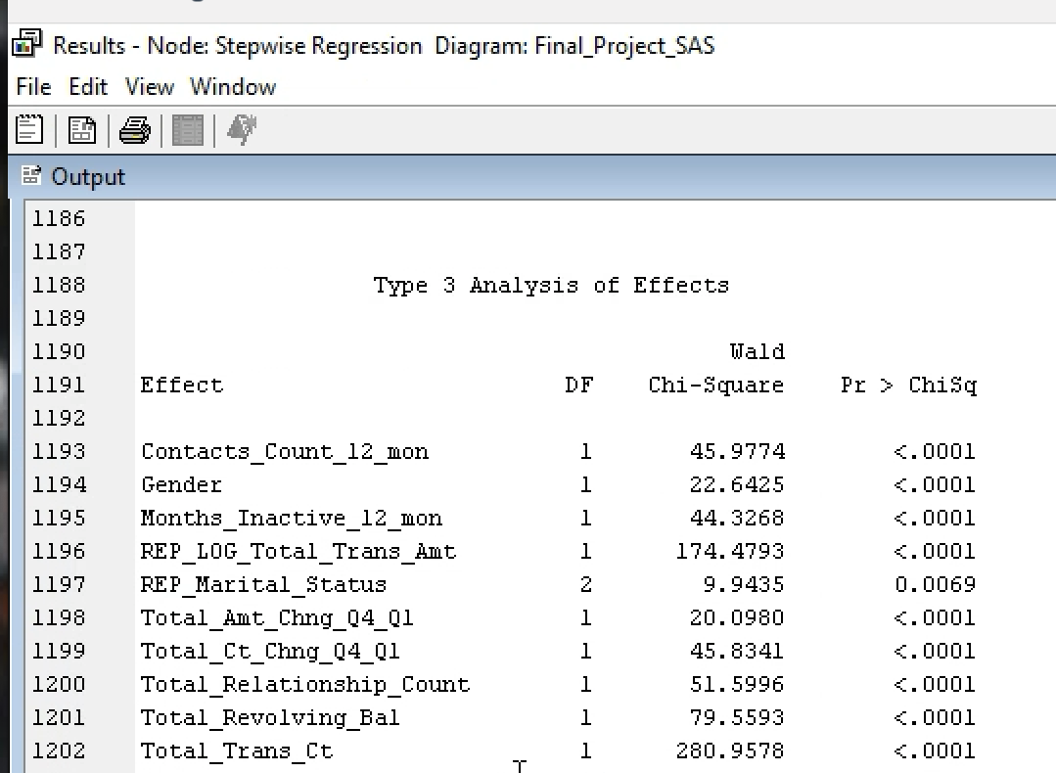

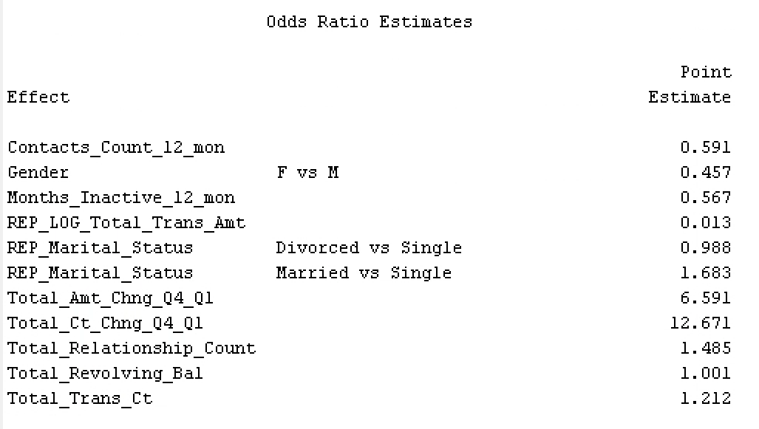

Odds ratios estimate for Stepwise regression is as follows:

* Female has 54% chance of being churned compared to male.
* Customers who are inactive for 12 months on books have 43% chance of churn.
* People who are single have a churn rate of 1.2% than people who are divorced.
* Contacts count in 12 months has 41% less chance of churning.
* Total relationship counts increases churning by 49%.

Internal event (customer activity) variable - if the account is closed then 1 else 0.

|  |  |  |
| --- | --- | --- |
| Sr. No | Regression model | Misclassification Rate (Validation Data) |
| 1 | Full regression | 0.143296 |
| 2 | Forward Regression | 0.140221. |
| 3 | Backward Regression | 0.143296 |
| 4 | Stepwise Regression | 0.140221 |

Overall forward regression and stepwise regression has the best misclassification rate of 0.140221 in the regression model compared to other models.

## 7.3 Neural Networks

A Neural Network model is as similar as regression but with flexible addition to model virtually any association between input and target variables. Our dataset consists of consistent data, so we do not have to worry about imputing or transforming variables for the requirement of models. To approximate any continuous association between inputs and the target, 9 neural network models with different configurations will be applied to our data. The best model will be filtered out by comparing the MISC (Misclassification rate) and the model selection criteria will be as default profit and loss. We will initiate the analysis by comparing the model to find either preliminary training can be helpful to achieve high accuracy and apply the configurations throughout the later models. Maximum iterations will be 50 for all the models expect one with 100 to compare the result.

### 7.3.1 Model with preliminary training enable vs disable

Applying settings:

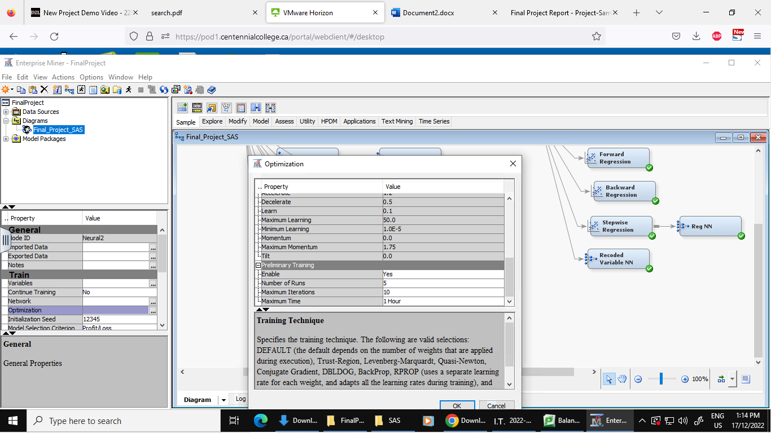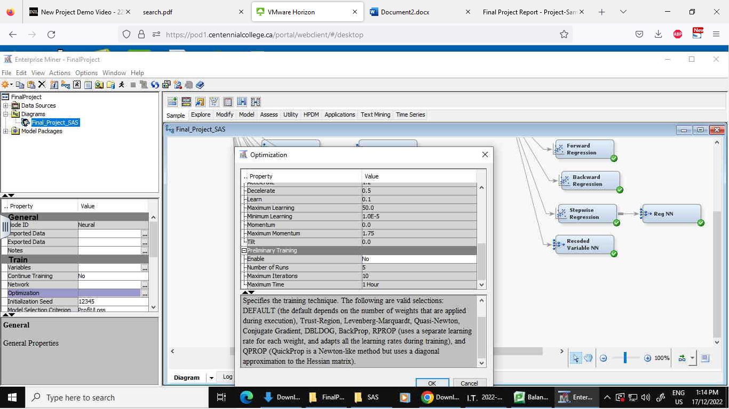

Results:

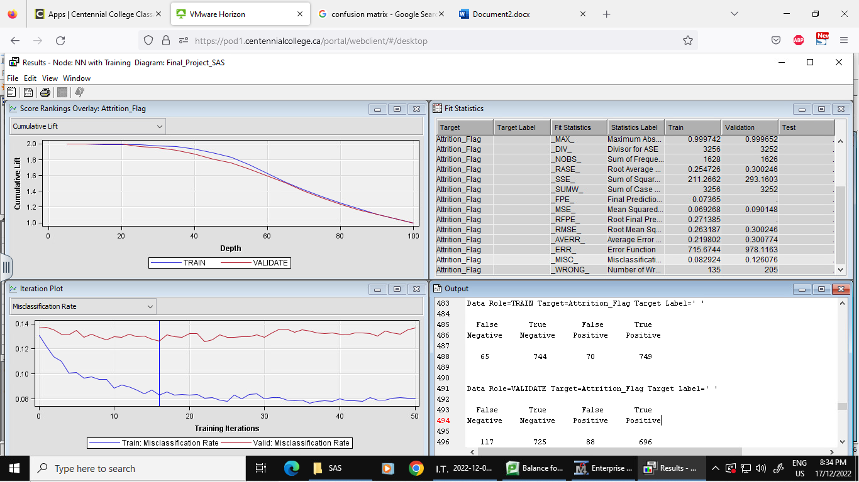

Outcome: After the comparison of above models, model with training enabled has the MISC of 0.126076 while the model with training disabled has MISC of 0.108856. Thus, we should disable the training for further models to get better accuracy.

First model Misclassification rate for negative class: 0.138954

Second model Misclassification rate for negative class: 0.117788

### 7.3.2 Decision tree neural network

Since we already have our decision tree, we can now connect our node to the best tree we have and apply the settings according to above outcomes.

Result:

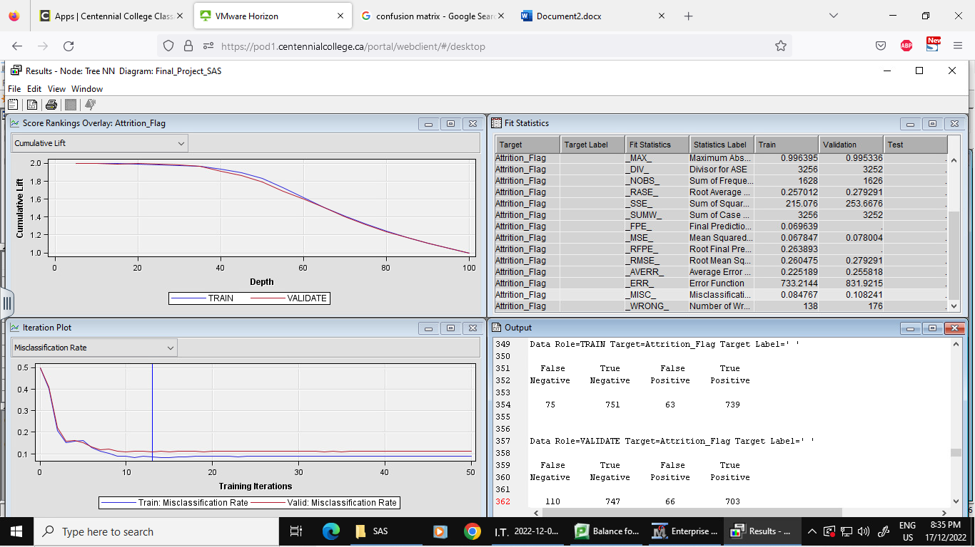Outcome: The new ASE for this model is 0.108241. By far the best neural network model.

Misclassification rate for negative class: 0.128354

### 7.3.3 2 Hidden unit's neural network

As neural networks work better due to hidden layers, to get a better result, we will start by assigning 2 hidden units to the data partition.

Applying setting:

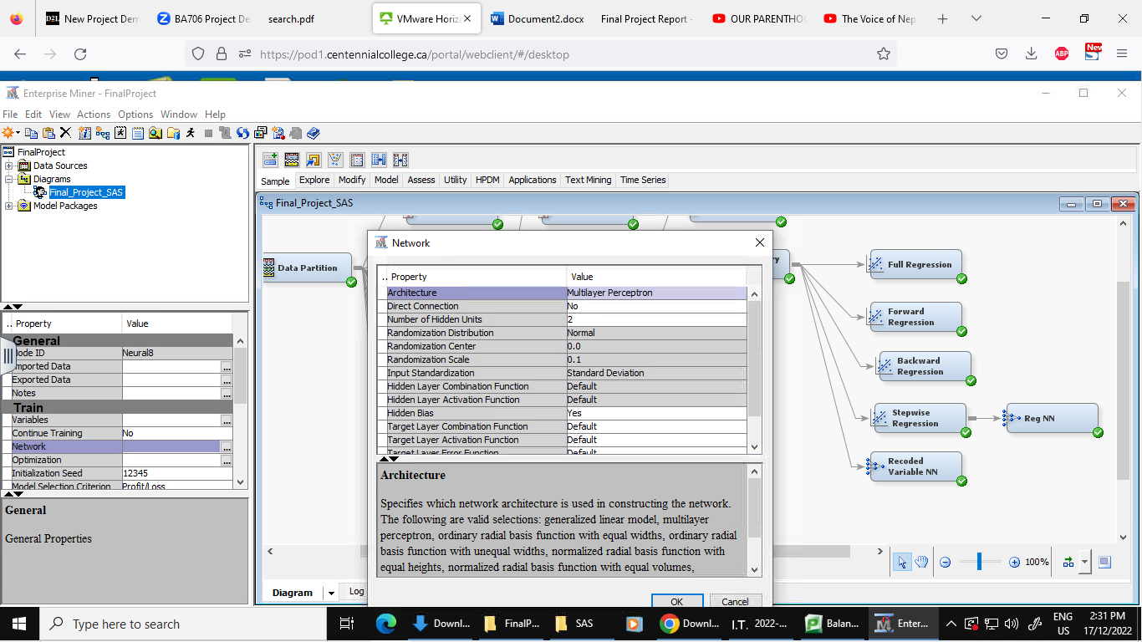

Result:

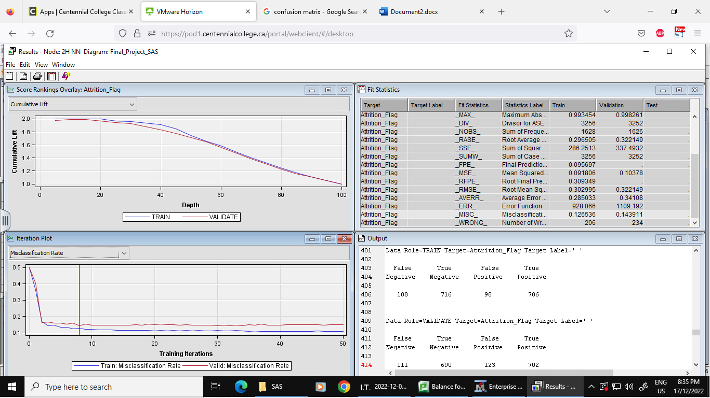Outcome: The ASE for our model with 2 hidden units is 0.143911. Not better than previous models so we will just add up the hidden units until it gives the constant result, or the ASE rise again.

Misclassification rate for negative class: 0.138576

### 7.3.4 4 Hidden unit’s neural network

Applying setting for 4 hidden unit:

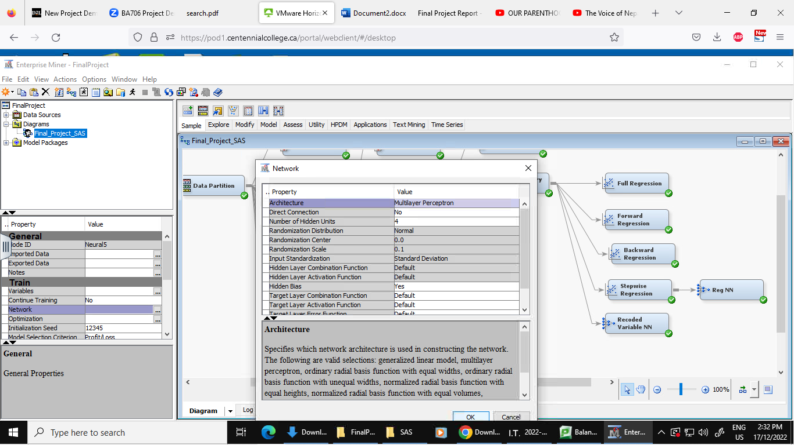

Result:

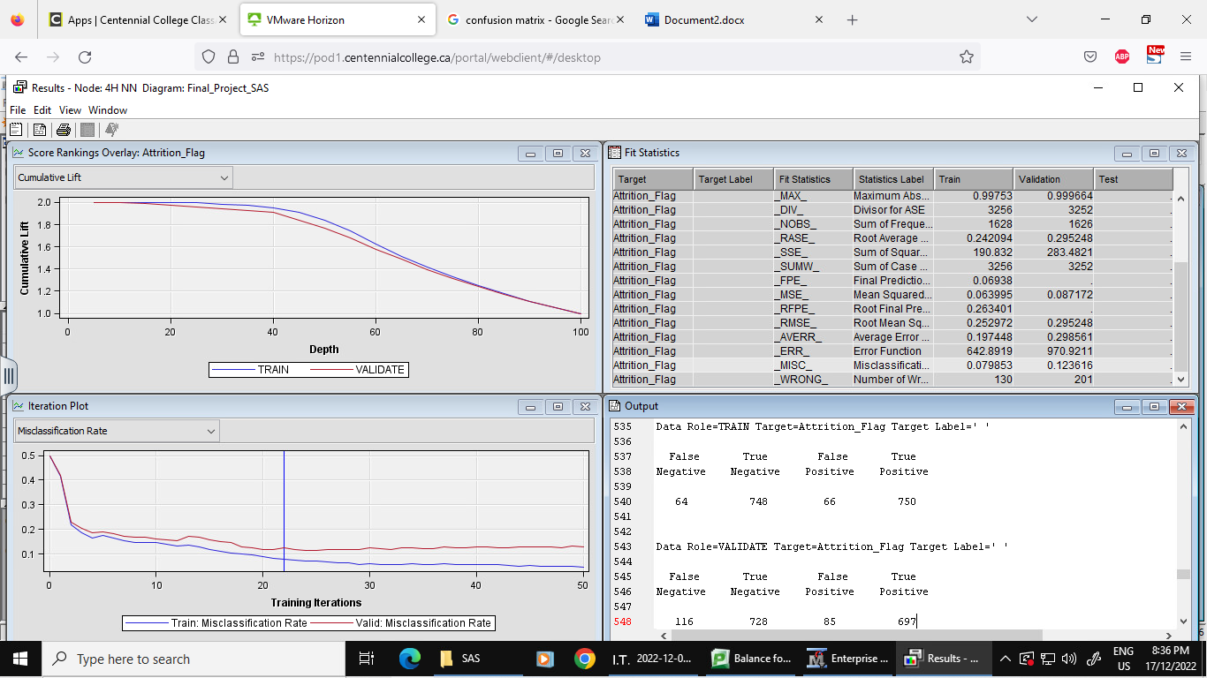Outcome: For this model with 4 hidden units, the ASE is 0.123616 - Better than 2 hidden units but not better than model connected with decision tree. Thus, we will add more hidden units.

Misclassification rate for negative class: 0.137440

### 7.3.5 6 Hidden unit’s neural network

Applying setting for 6 hidden units:

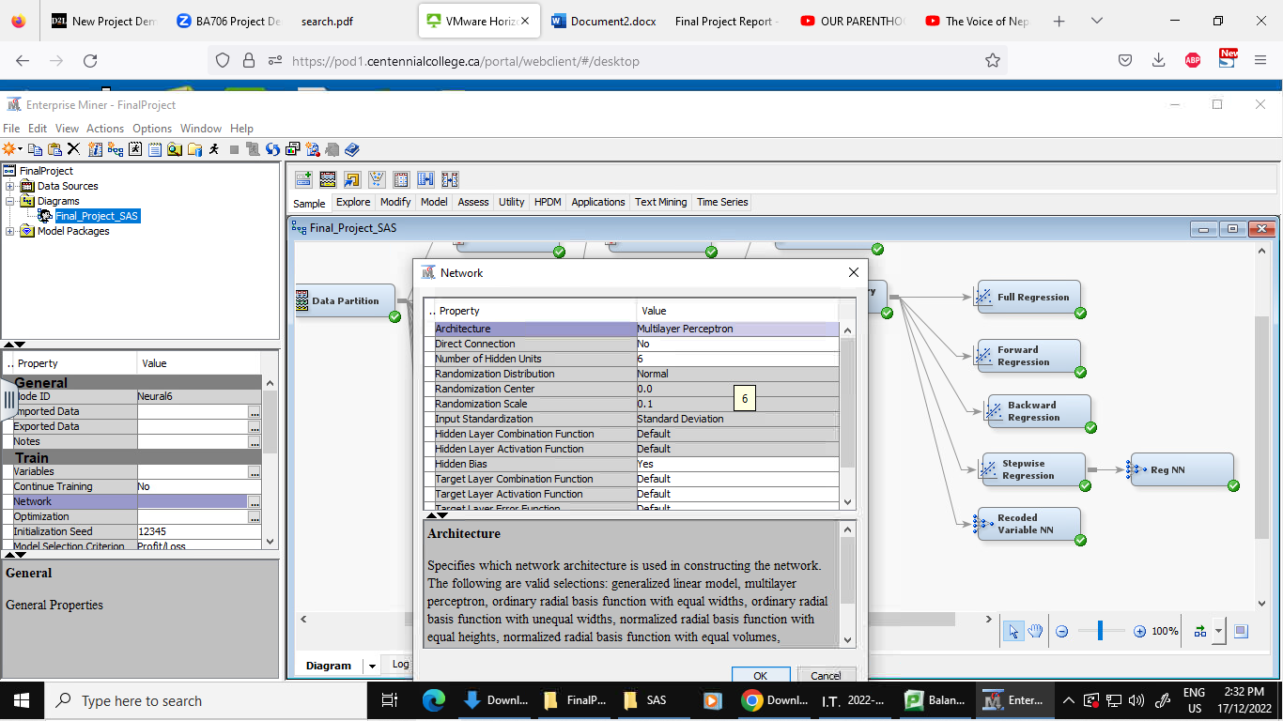

Result:

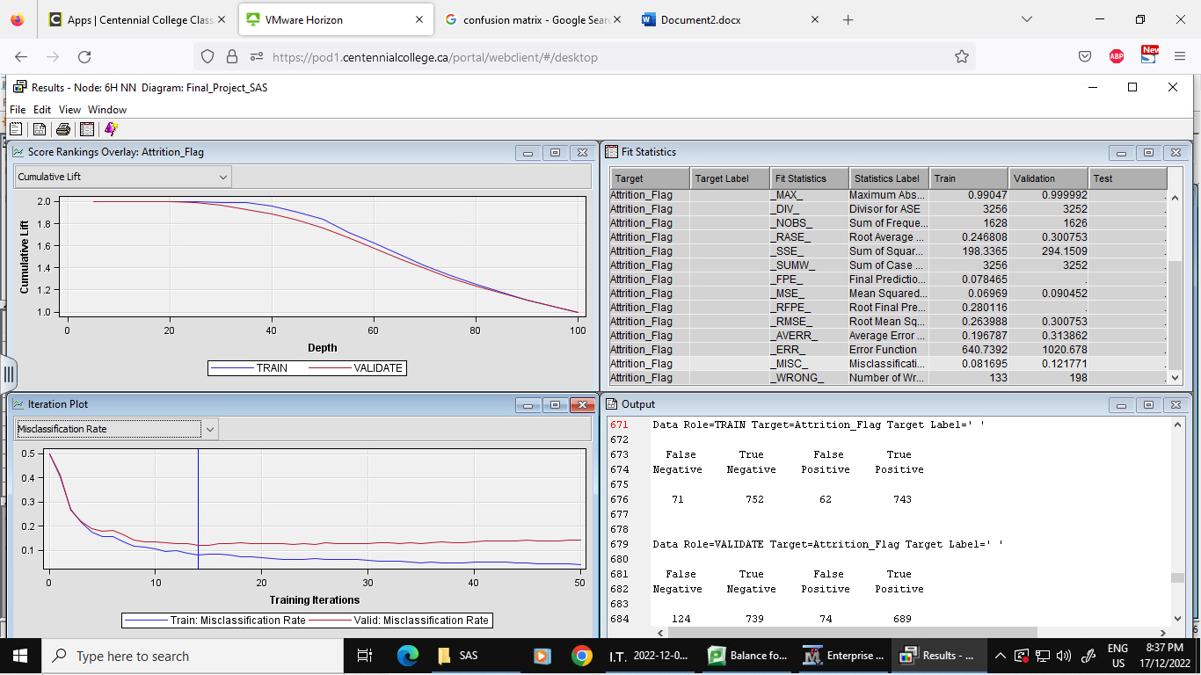Outcome: This model, with 6 hidden units, has an ASE of 0.121771, which is lesser than the previous model with lower units. Thus, we will settle down at model with 6 hidden units because after this model the MISC stays constant for every interval.

Misclassification rate for negative class: 0.143684

### 7.3.6 100 Iteration neural network

To check if the accuracy increases with increase in iteration value, we set it to 100 from 50 with default hidden units.

Applying setting for maximum iteration to be 100:

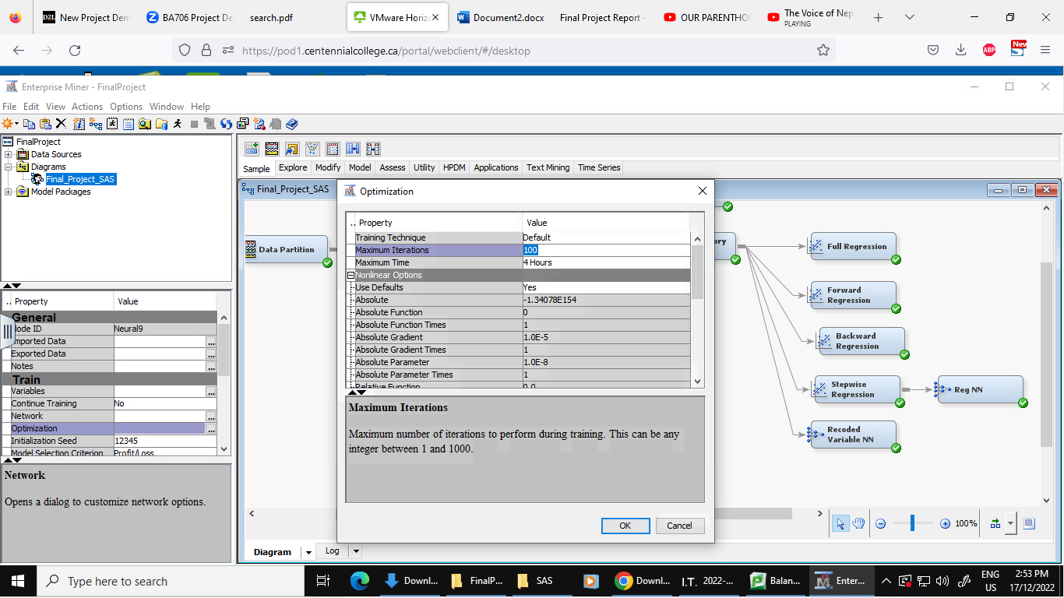

Result:

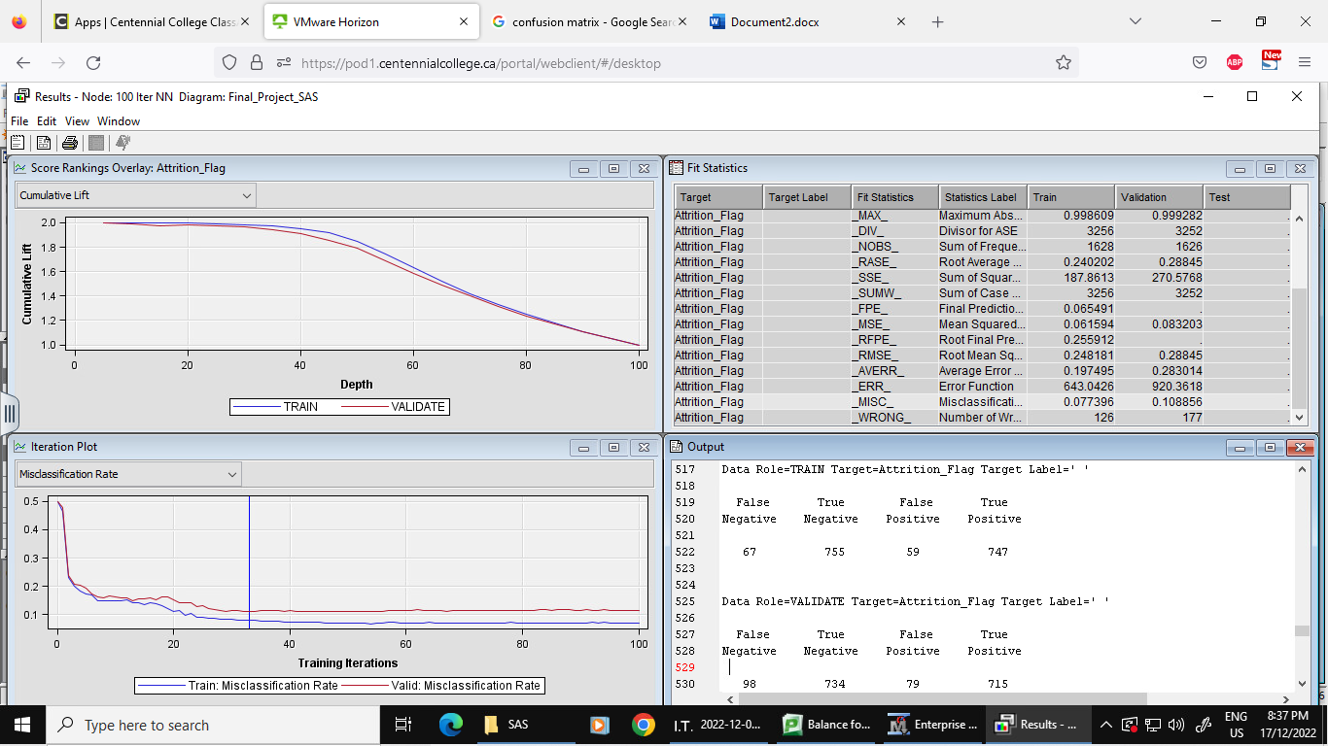

Outcome: Our new model with maximum iteration has an MISC of 0.108856. Thus, the same as the initial model with no training but better than the model with hidden units higher than 3 with 50 iterations.

Misclassification rate for negative class: 0.117788

### 7.3.7 Recoded variable neural network

Connecting model to existing recoded card category:

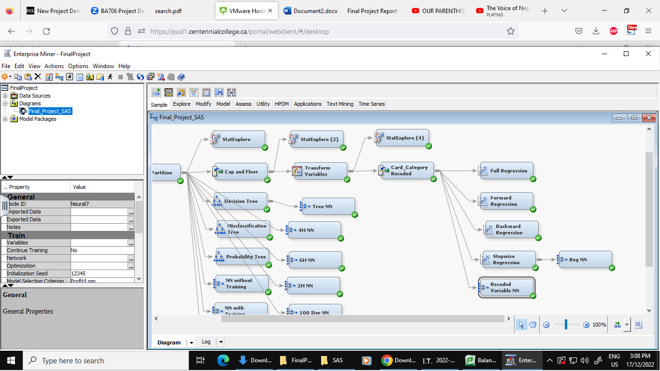

Result:

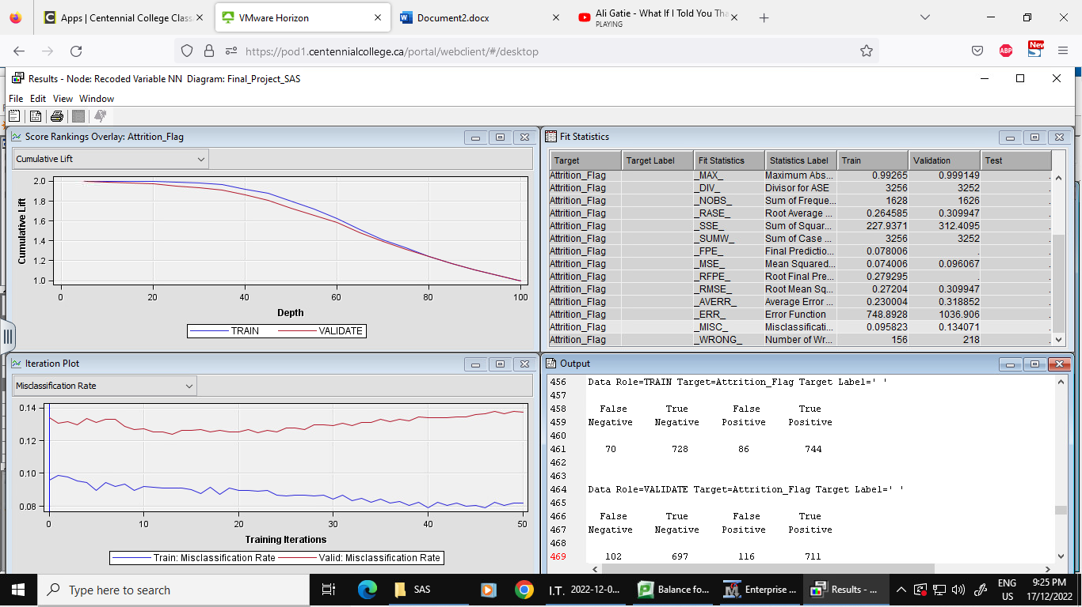

Outcome: Our new neural network model connected with the recoded card category has an MISC of 0.134071. Thus, the second highest MISC till now after model with 2 hidden units.

Misclassification rate for negative class: 0.127659

### 7.3.8 Stepwise regression neural network

In search of better accuracy, we then connected the neural network model with the best regression model which is stepwise (Can be seen in figure above).

Result:

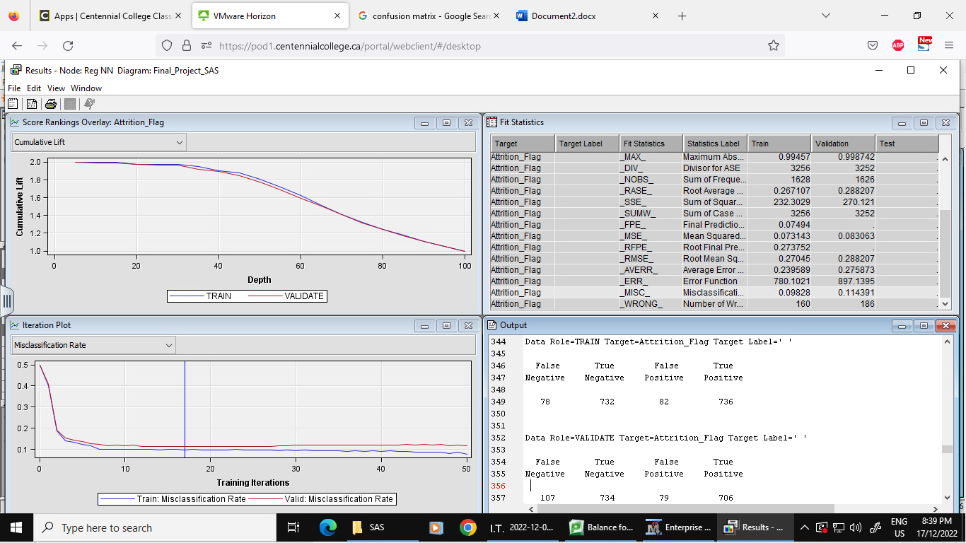Outcome: This model with node connected to stepwise regression has the MISC of 0.114391. Thus, the second-best model out of all the neural network models in assessment of MISC.

Misclassification rate for negative class: 0.127229

### 7.3.9 Summary table for neural network model

|  |  |  |  |
| --- | --- | --- | --- |
| **Neural Network Models** | **Iterations** | **Hidden units** | **MISC** |
| **NN with Training** | 50 | 3 | 0.126076 |
| **NN without Training** | 50 | 3 | 0.108856 |
| **Tree NN** | 50 | 3 | 0.108241 |
| **2H- NN** | 50 | 2 | 0.143911 |
| **4H-NN** | 50 | 4 | 0.123616 |
| **6H-NN** | 50 | 6 | 0.121771 |
| **100 Iter NN** | 100 | 3 | 0.108856 |
| **Recoded variable NN** | 50 | 3 | 0.134071 |
| **Reg NN** | 50 | 3 | 0.114391 |

Overall, the best neural network model is the model connected with decision tree with an MISC of 0.108241, having iteration and hidden units of 50 and 3. And the model with the highest MISC is the model with 2 hidden units.

### 7.3.10 Model Assessment

Does ordinal encoding help improve performance of the best Regression / Neural Networks model?

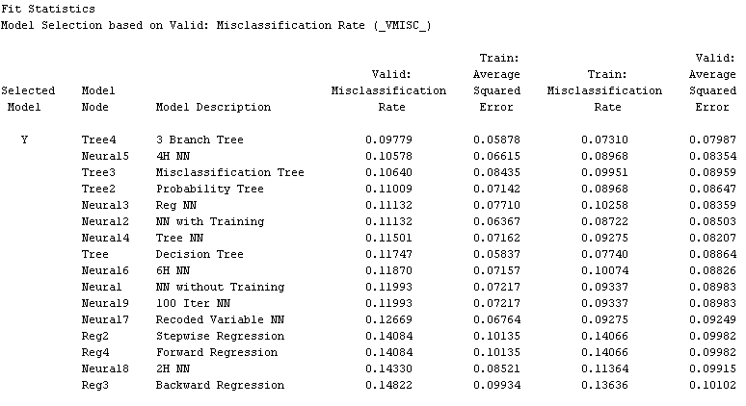

Among the Neural Networks and Regression models, the neural networks model with 4 Hidden layers provided the lowest misclassification rate and hence we will compare this model with the same configuration for ordinal encoded variables and one hot encoded variable and compare results respectively.

Neural Networks model with 4 Hidden Layers – Model without ordinal Encoding:

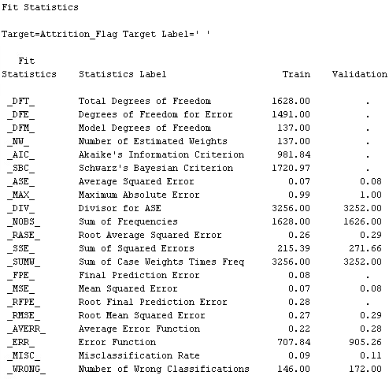

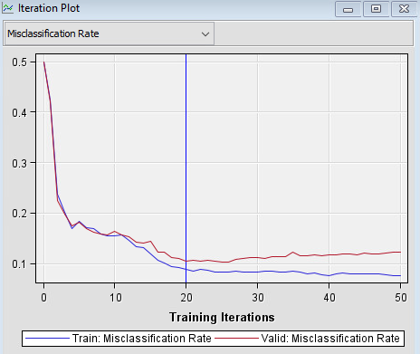

The neural networks model with 4 hidden units was the best model among the regression and neural networks models. With a misclassification rate slightly higher than the overall best model. Although neural networks lack explain ability, they can be very powerful machine learning approaches. In our case, the misclassification rate converged to the lowest at around 20 iterations after which it was overfitting. All categorical variables had been one hot encoded which resulted in a model with a lot of variables. This can be computationally expensive as well.

Neural Networks model with 4 Hidden Layers – Model with ordinal Encoding:

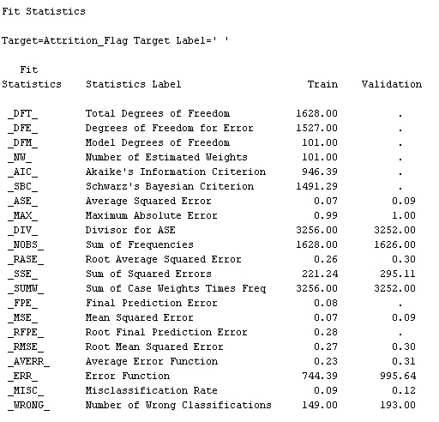

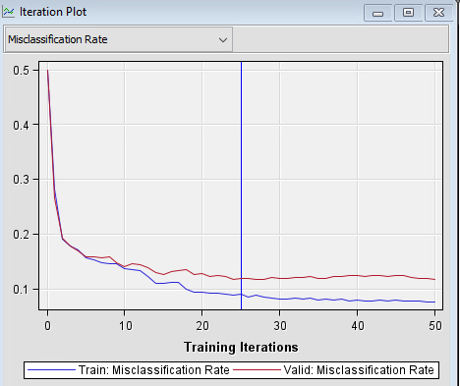

Although, this model included relatively lower number of variables by a factor of 10 which reduced the dimensionality drastically, performance of the model was lower as compared to the one without ordinal encoding. Ordinal encoding may sound logical from a domain perspective, but while modelling, independent flag variables for each class created more impact on the target rather than ranking the respective variables. The model converged to the lowest misclassification rate at 25 iterations post which there were signs of overfitting. But in this case the extent of validation misclassification rate after reaching the minima was not as drastic as in the case of the previous model.

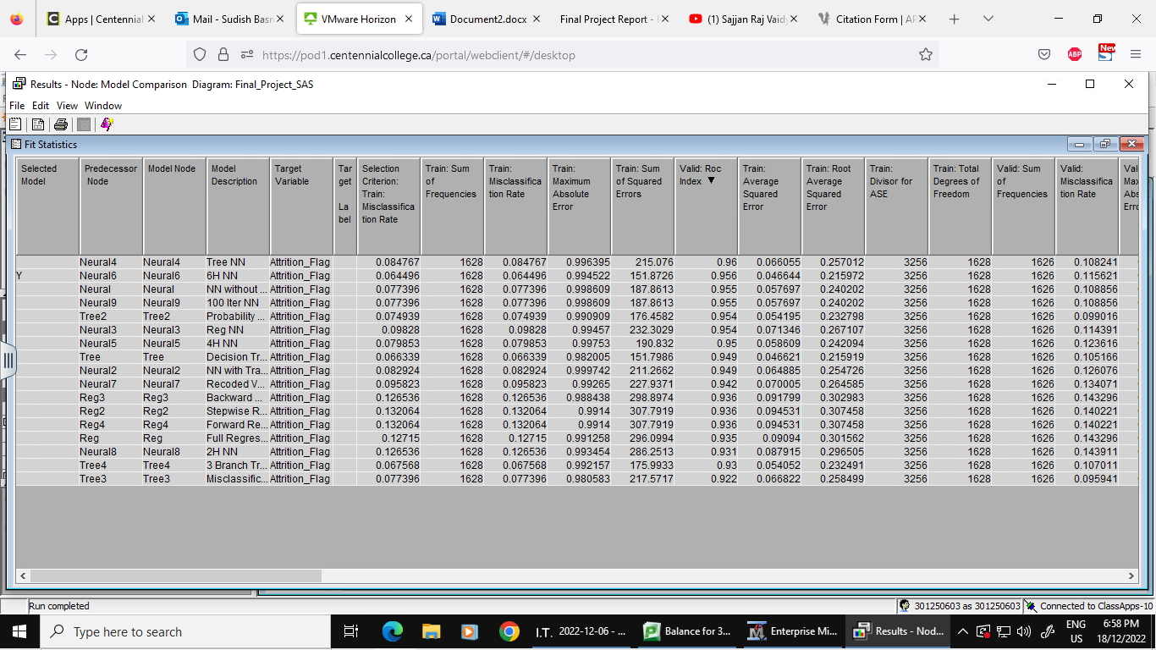

# 8. Models Comparison

All the models for this churn analytics which includes decision trees, regression and neural networks are further connected to the model comparison node to draw the best performance model. Comparison model is set up to use Misclassification for the selection statistic. The best performer will be filtered by viewing roc result and ranking according to other model assessment metrics.

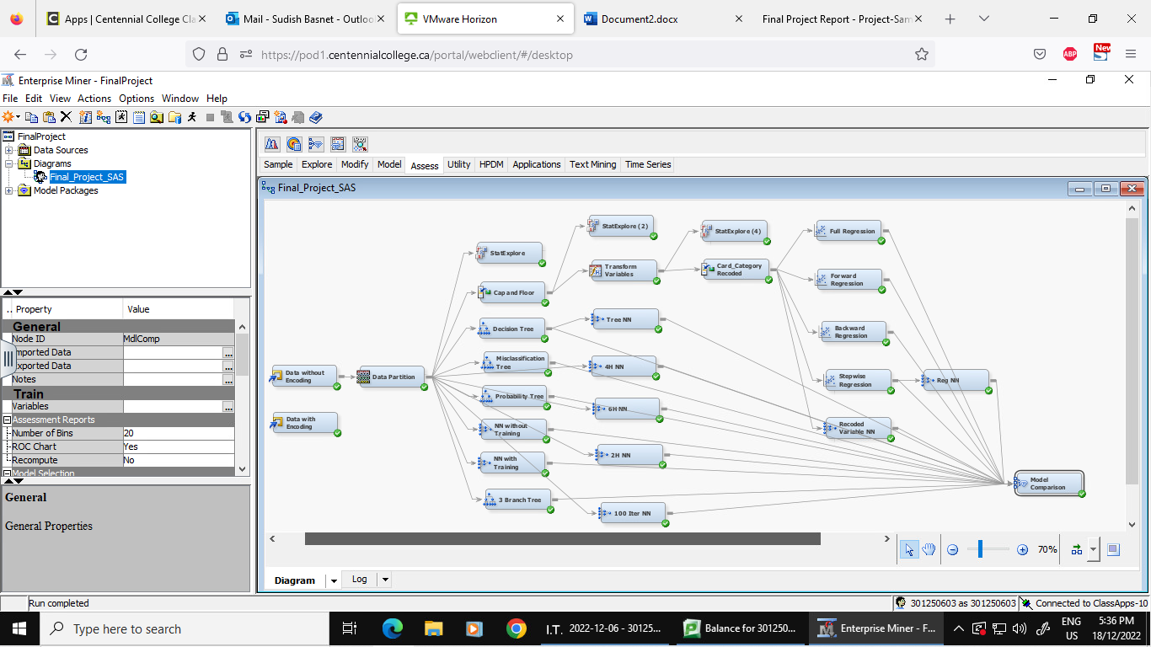

ROC curve for the models

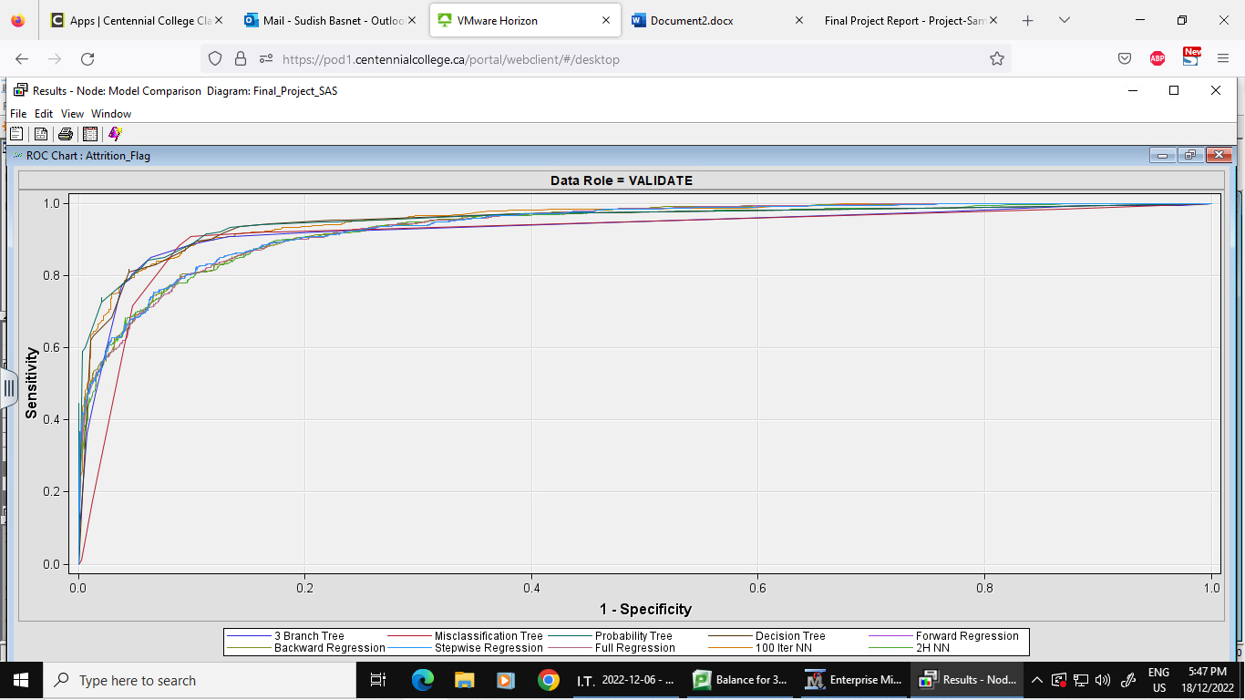

Fit Statistics

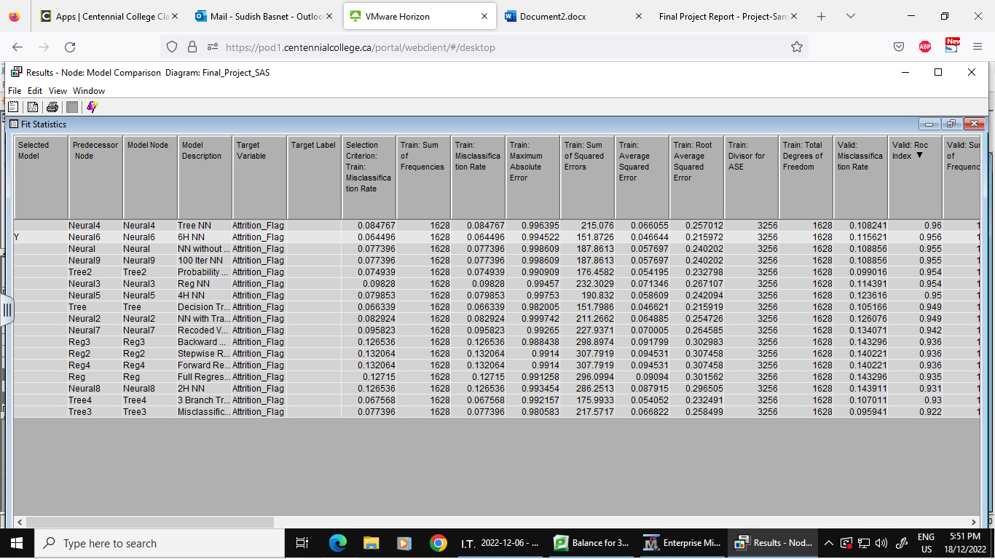

Outcome: According to the ROC, the best model is set to be misclassification tree (Tree 3) with ROC index 0.922 on validation. It also has the best misclassification rate of 0.095941. With the selection criteria of training data for misclassification rate with selection depth 10, neural network with 6 hidden units is better with a rate of 0.064496. Overall, backward, forward, and stepwise regression has the same ROC index of 0.936.

# 9. Conclusion

For the churn analytics of credit card users, we have built 17 models in total which consists of 4 decision tree models, 4 regression models and 9 neural network models. Besides a few skewed variables, our dataset did not have any missing values. Three categorical variables (Education level, Marital Status, and Income Category) where the fields labelled were unknown and considered as missing were imputed with mode. 4 Variables which were skewed includes Average utilization Ratio, Credit Limit, Total Transaction Amount, and Average open to buy. We followed our rational statistical technique to resolve the skewness which was that the ones with higher skewness statistic were log transformed and the ones with lower skewness statistic were handled using cap and floor. While connecting the node for each model, we came to conclusion that the best models with higher accuracy were the decision trees, followed by neural network and regression.

According to misclassification rate for model assessment, out of 4 decision trees, misclassification is found to be the best one, and for neural network model connected with best tree is the most accurate one. For regression, forward and stepwise are competing. In consideration of ROC index, misclassification tree is the best one and the worst one is tree neural network having index 0.9222 and 0.96 respectively. Based on the result from the decision tree and odds ratio from regression, Total transaction count, total revolving balance, and total transaction amount play an important role in deciding if a customer would churn or not. With our analysis we found out that for a customer having total transaction count less than 56.5 and total revolving balance less than $634, there is a 93% chance of the customer churning. Beside this, male has 59% chance of churning compared to female and people who are educated are 21% less likely to churn against people who are uneducated.

We need to minimize the false positive for our model as we cannot afford a customer to be attributed as churned when our model says that the customer will not churn; this might be a loss to the company. Also, for our business purposes we need to focus on the customer's number. So, the model with lowest false positive is selected as the attired person is labeled as 1.

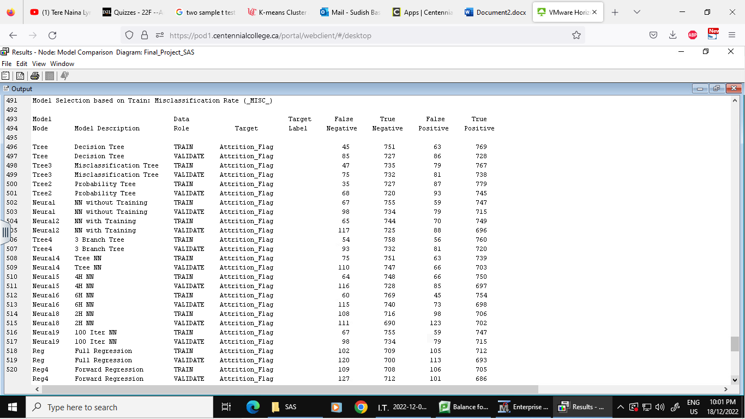

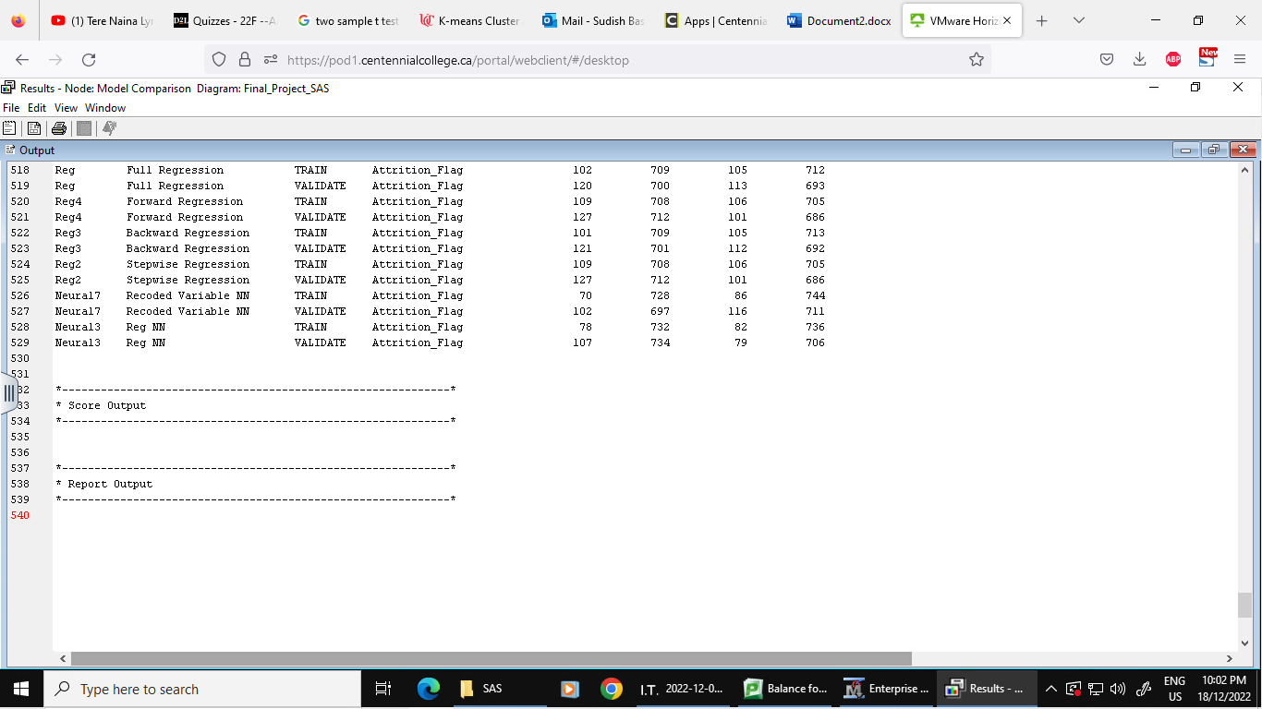

# 10. Business Report

To minimize the number of customers who are withdrawing the use of credit cards with respective financial institutions, officials should focus on major customers who have revolving balance less than $634 and simultaneously the customer whose count of transactions per month is below 57. The marketing department can send some promotional messages or email to such customers so that they do not churn and are retained. This overall saves the time and money to be invested in all the credit card users and be effective as well.

Besides this, if the institution wants then they can focus on other groups of people based on gender, education, marital status, and card type but these are just the minor groups for prioritizing than customers having low revolving balance and transaction.

# 11. References

* *Credit Card Customers Prediction*. (2022, October 30). Kaggle. <https://www.kaggle.com/datasets/whenamthancodes/credit-card-customers-prediction> (DATA SET)
* Logan, H. (2022, July 15). *What You Need to Know About Credit Card Churning in Canada*. NerdWallet Canada. https://www.nerdwallet.com/ca/credit-cards/what-is-credit-card-churning
* Kusumowibowo, T. S. (2022, October 7). *Credit Card Customer Churn Predictive Analytics - Dev Genius*. Medium. https://blog.devgenius.io/credit-card-customer-churn-predictive-analytics-b012ff8c385d
* *Churning: Definition and Types in Finance*. (2022, January 31). Investopedia. <https://www.investopedia.com/terms/c/churning.asp>